Microsoft Digital Civility Index (DCI) 2017 – South Africa



The 2017 Civility, Safety and Interaction Online study examines the extent of negative behaviors and online interactions and their consequences. These results build on last year’s study and were based on interviews with teens ages 13-17 and adults ages 18-74. The scope of research increased to encompass 23 countries and 20 online risks (nine newly included countries, three added risks).[1]

Themes for 2017

Risk exposure was above the global averages

1. 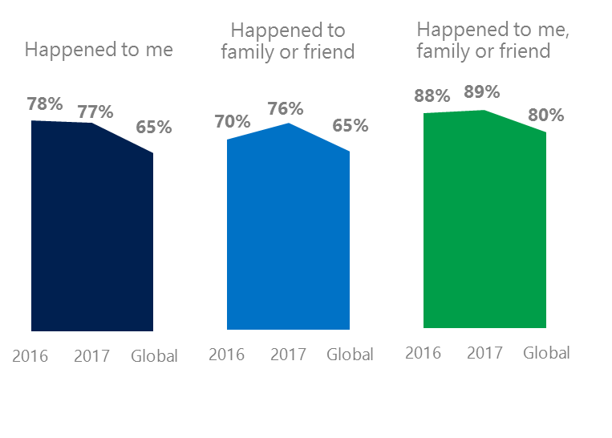The level of online risks held steady YOY for respondents but increased for their family and friends since 2016. South Africa had the second highest online risk exposure (Peru, 78%) among all countries surveyed.
2. Targets of online risks often named acquaintances, friends or family as perpetrators.
3. Encouraging signs emerged as people began to evolve their approaches towards the challenges of negative online interactions.
4. Teens (ages 13-17) had the highest lifetime exposure to online risks while Baby Boomers (ages 50-74) reported the highest levels of civil behavior.
5. Harassment and their consequences were higher for females than males.

Unwanted contact fell since 2016

1 South Africa DCI was 77%

South Africa ranked 22th out of 23 countries for exposure to online risks. In 2017, we maintained and added two risks to the Intrusive category and one risk to Behavioral. Without these changes, DCI would have been six points lower to 71%.

**Intrusive:** The addition of Hoaxes, Scams & Frauds (44%) and Misogyny (5%) pushed the category higher by four points YOY. Despite a decline, South Africa had the third highest rate of Unwanted Contact among all countries surveyed.

**Behavioral:** Behavioral risks held steady YOY led by a four-point decline in being Treated Mean. Microaggression (14%), new in 2017 was slightly above the global average.

**Sexual:** Over one in three respondents experienced a Sexual risk driven by Unwanted Sexting Received or Sent (31%) – unchanged since 2016.

**Reputational:** Like Sexual risks, Reputational risks held steady YOY led by Doxxing and Damage to Personal Reputation.

2Targets of online risks often named 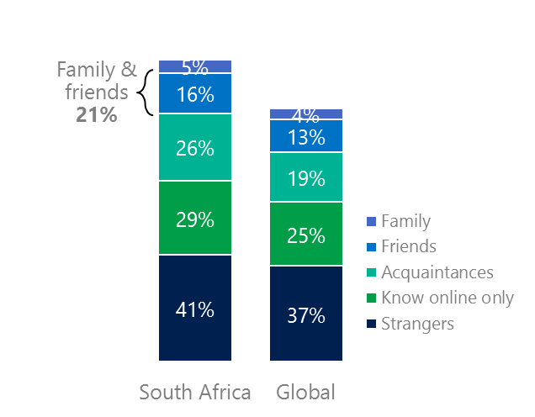people they knew as perpetrators

21% of perpetrators were family or friends

(among those who said they were treated unsafely or uncivilly)

Although many believe online risks are facilitated by the anonymity provided by the internet, these experiences often involved people they knew personally including family or friends (21%) compared to 17% globally. 44% had met their perpetrator in real life about the same as 2016 and nine points below the global average (53%). Among those who had met their perpetrator, over eight in 10 (81%) met before the risk occurred. Familiarity with the perpetrator in real life was related to an increased exposure to online risks. The average number of risks was 82% higher among those who had met the perpetrator in real life vs. those who had not (5.9 vs. 3.2).

Nearly eight in 10 respondents (77%) suffered at least one negative consequence from online risks with less trusting of people online and offline being the most common. Familiarity with the perpetrator in real life also affected exposure to consequences. Among those who had met their perpetrator in real life, 64% lost trust in others online and life became more stressful (58%). This compared to a loss of trust in others online (43%) and offline (26%) for those who had not met the perpetrator in real life.

Loss of trust was the biggest consequence

3 Encouraging signs emerged

South Africa exceeded or met the global averages for civil behavior as defined by the Microsoft Digital Civility Challenge, announced in 2017. Respondents were 14 points higher on standing up for myself, nine points higher on paused before replying to something I disagreed with.

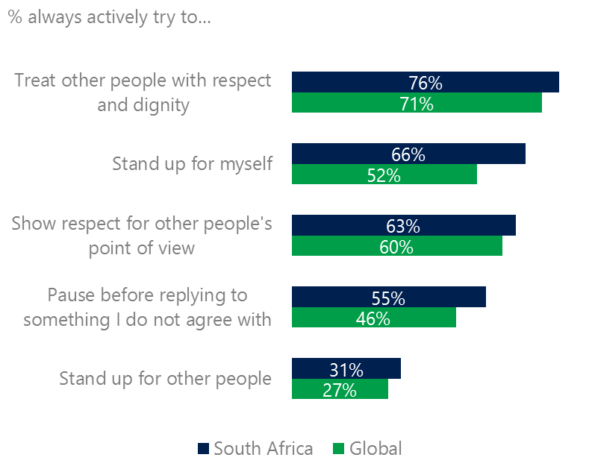Nearly six in 10 respondents (58%) said they were extremely or very confident in managing online risks about the same YOY and 12 points above the global average (46%). South Africa ranked third overall behind Hungary (76%) and the U.S. (60%). 40% of respondents knew where to find help if needed, up three points YOY but five points under the global average (45%).

Reports of civil behavior were widespread

Males were more likely than females to stand up for themselves (72%, 60%) while females were more likely than males to pause before replying to something they disagreed with (58%, 52%). Adults were more likely than teens to pause before replying to something they disagreed with (61%, 48%).

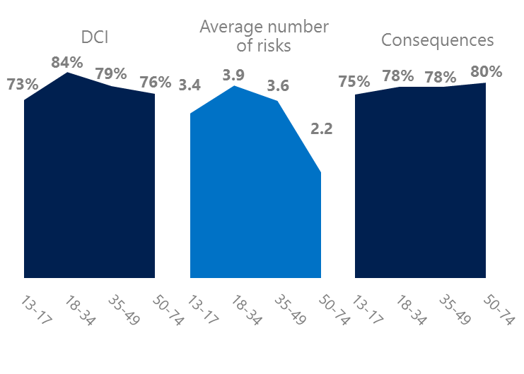4 Millennials had the highest exposure to online risks

Boomers suffered the most consequences

Millennials (ages 18-34) had the highest levels of risk exposure as measured by DCI (84%), average number of risks (3.9) and tied for the second highest level of consequences from risks (78%). 19% of Millennials were extremely or very concerned about online risks, about the same as other age groups. 14% said they were not treated in a safe or civil manner online which was the second highest among all age groups. These high levels of risk exposure coincided with some of the lowest levels of civil behavior online as defined by the Microsoft Digital Civility Challenge, announced in 2017. Millennials were less likely than other age groups to treat others with respect and dignity, respect other people’s point of view or stand up for other people.

Boomers were the most respectful & civil

Conversely, the Baby Boom generation (ages 50-74) had the lowest average number of risks (2.2) and had the second lowest DCI (76%). More importantly, this age group reported some of the highest levels of civil behavior online including treating others with respect and dignity, respecting other people’s point of view and standing up for themselves.

5 Harassment and its consequences were higher for females than males

Over six in 10 respondents experienced one or more forms of harassment. This study defined harassment as Unwanted Contact, Unwanted Sexting, Online Harassment, Cyberbullying or Misogyny. All forms of harassment were higher for females than males with the largest gaps being in total harassment (72%, 59%), Unwanted Contact (60%, 49%) and Unwanted Sexting (35%, 27%). Adults were more likely to report Unwanted Contact and Unwanted Sexting while teens reported higher levels of Online Harassment and Cyberbullying.

Over six in 10 people were harassed

The consequences from online risks affected females at a higher rates than males. Females scored 15 points higher on lost trust in other people online, life became more stressful, 11 points higher on less trusting of people offline and nine points higher on became depressed.

Definitions of online risks

1. **Cyberbullying:** When the Internet, phones or other devices are used to send or post text, images, or video intended to hurt, embarrass or intimidate another person.
2. **Damage to Personal reputation:** Damage or destruction to the image created of you through PERSONAL information you or others shared online in blogs, postings, pictures, tweets, videos, etc.
3. **Damage to Professional/Work reputation:** Damage or destruction to the image created of you through work information you or others shared online in blogs, postings, pictures, tweets, videos, etc.
4. **Discrimination:** A person who is discriminated against or excluded based on gender, ethnic origin, religion, race, disability, or sexual orientation.
5. **Doxxing:** The process of collecting and distributing or posting information about a person (e.g., name, age, email, address, phone number, photographs, etc.) without their permission.
6. **Hate speech:** speech that attacks a person or group based on gender, ethnic origin, religion, race, disability, or sexual orientation.
7. **Hoaxes, scams, frauds:** The spreading of false rumors (e.g., chain letters), criminal attempts to obtain personal information often for monetary gain (e.g., phishing scams), malicious emails disguised as someone you know (e.g. virus).
8. **Microaggression:** Casual insults made towards any marginalized group in society (e.g., religious or ethnic minorities, women, LGBT, people with disabilities, etc.).
9. **Misogyny**: An expression or demonstration of dislike, contempt for, or ingrained prejudice against women.
10. **Online harassment:** Threats or other offensive behavior (not sexual solicitation) sent online or posted online for others to see.
11. **Revenge pornography:** A sexually explicit portrayal of one or more people distributed without their consent.
12. **Sextortion:** When someone threatens to distribute your private and sensitive material if you don’t provide them images of a sexual nature, sexual favors, or money. The perpetrator may also threaten to harm your friends or relatives by using information they have obtained from your electronic devices unless you comply with their demands.
13. **Sexual solicitation:** A person who requests to engage in sexual activities or sexual talk or to give personal sexual information that is unwanted.
14. **Swatting:** The act of deceiving emergency services (e.g., police, fire, medical) into sending an emergency response based on the false report of an ongoing critical incident or crime.
15. **Terrorism recruiting:** An attempt by a terrorist or terrorist organization to recruit a person for the purposes of causing harm.
16. **Treated Mean:** Words or messages sent to another person online that are unkind, unfair or malicious.
17. **Trolling:** A deliberate act to make someone mad or angry using online or social media comments in a clever, but deceitful manner.
18. **Unwanted Sexting Sent:** I sent unwanted sexually explicit messages and imagery.
19. **Unwanted Sexting Received:** Received unwanted sexually explicit messages and imagery.
20. **Unwanted contact:** Being personally contacted (by phone or in person) by someone who obtained your information online but without inviting them to contact you.

1. 9 new countries: Argentina, Colombia, Peru, Hungary, Ireland, Italy, Japan, Malaysia, Vietnam

   14 Wave 1 countries: Australia, Belgium, Brazil, Peru, China, France, Germany, India, South Africa, South Africa, Turkey, UK, U.S.

   3 new online risks: Hoaxes, Frauds and Scams as one collective risk, Microaggression, Misogyny