Microsoft Digital Civility Index (DCI) 2017 – Russia



The 2017 Civility, Safety and Interaction Online study examines the extent of negative behaviors and online interactions and their consequences. These results build on last year’s study and were based on interviews with teens ages 13-17 and adults ages 18-74. The scope of research increased to encompass 23 countries and 20 online risks (nine newly included countries, three added risks).[1]

Themes for 2017

Risk exposure was above the global averages

1. 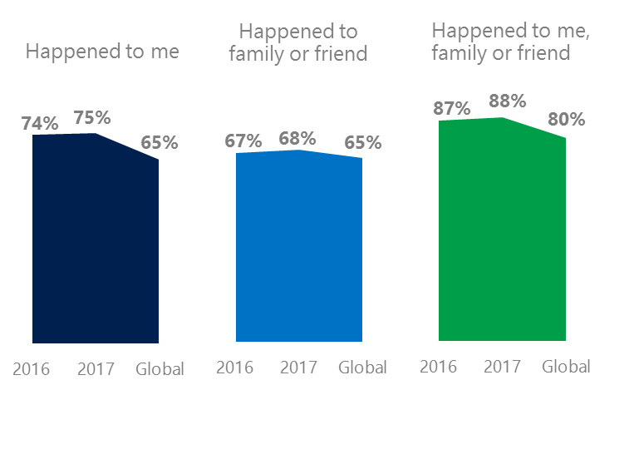The level of online risks held steady YOY for respondents and their family and friends since 2016. Russia experienced risks at rates above the global averages.
2. Targets of online risks often named acquaintances, friends or family as perpetrators.
3. Managing online risks were a challenge for most respondents and only one-third knew where to find help if needed.
4. Teens (ages 13-17) had the highest lifetime exposure to online risks while Baby Boomers (ages 50-74) reported the highest level of civil behavior.
5. Consequences from bullying and harassment were higher for females than males.



Behavioral & Reputational risks fell YOY

1 Russia DCI was 75%

Russia ranked 19th out of 23 countries for exposure to online risks with DCI a point higher YOY. In 2017, we maintained and added two risks to the Intrusive category and one risk to Behavioral. Without these changes, DCI would have been seven points lower to 68%.

**Intrusive:** The addition of Hoaxes, Scams & Frauds (43%) and Misogyny (7%) pushed the category higher by six points YOY. Russia had the sixth highest rate of Intrusive risks among all countries surveyed.

**Behavioral:** Behavioral risks were down seven points YOY led by declines in being Treated Mean and Online Harassment. These declines were noteworthy given the addition of Microaggression (26%) which was 12 points above the global average. Russia had the second highest level of Behavioral risks behind only Turkey (59%).

**Sexual:** One in five respondents experienced a Sexual risk driven by Unwanted Sexting Received or Sent (16%). The category was 11 points below the global average.

**Reputational:** A drop in Doxxing drove the Reputational risk category down seven points YOY – equal to the global average.

2Targets of online risks often named 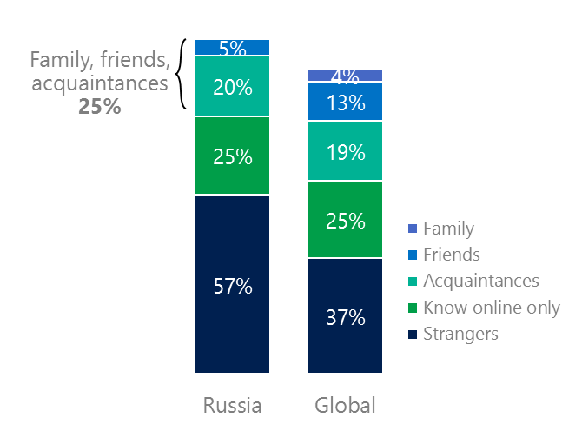people they knew as perpetrators

25% of perpetrators were family, friends or acquaintances

(among those who said they were treated unsafely or uncivilly)

Although many believe online risks are facilitated by the anonymity provided by the internet, these experiences often involved people they knew personally including family, friends or acquaintances (25%) compared to 36% globally. 77% had met their perpetrator in real life up 26 points YOY and higher than the global average (53%). Among those who had met their perpetrator, nearly eight in 10 (78%) met before the risk occurred. Familiarity with the perpetrator in real life was related to an increased exposure to online risks. The average number of risks was 29% higher among those who had met the perpetrator in real life vs. those who had not (4.4 vs. 3.4).

Over seven in 10 respondents (72%) suffered at least one negative consequence from online risks with less trusting of people online, life became more stressful and less trusting of people offline being the most common. Familiarity with the perpetrator in real life also affected exposure to consequences. Among those who had met their perpetrator in real life, 55% lost trust in others online and life became more stressful (41%). This compared to a loss of trust in others online (35%) and offline (27%) for those who had not met the perpetrator in real life.

Loss of trust was the biggest consequence

3 Respondents found it hard to manage online risks or where to find help if needed

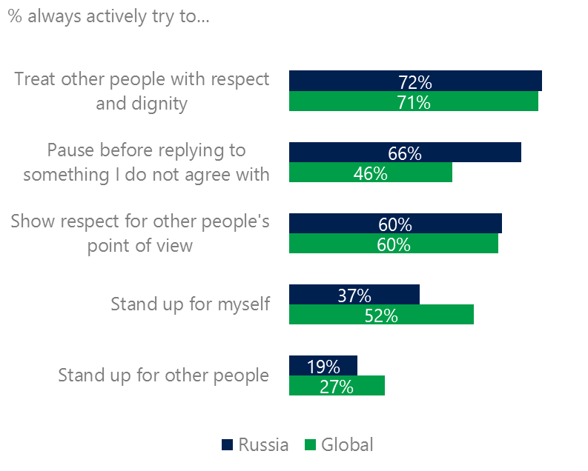Less than one in five respondents (17%) said they were extremely or very confident in managing online risks down eight points YOY and nearly 30 points below the global average (46%). 33% of respondents knew where to find help if needed, up three points YOY but 12 points above the global average of 45%.

Reports of civil behavior were widespread

The level of civil behavior as defined by the Microsoft Digital Civility Challenge, announced in 2017 were mixed compared to the global averages. Russia scored 20 points higher than the global average on paused before replying to something I disagreed with. This was the highest score among all countries surveyed. Russians were less likely to stand up for themselves or for other people.

Females scored higher than males on all civil behavior items except standing up for myself. They were more likely than males to treat others with respect and dignity (79%, 65%), respect other people’s point of view (68%, 53%), and pause before replying to something they disagreed with (71%, 61%), Adults were more likely than teens to treat others with respect and dignity and to respect other people’s point of view.

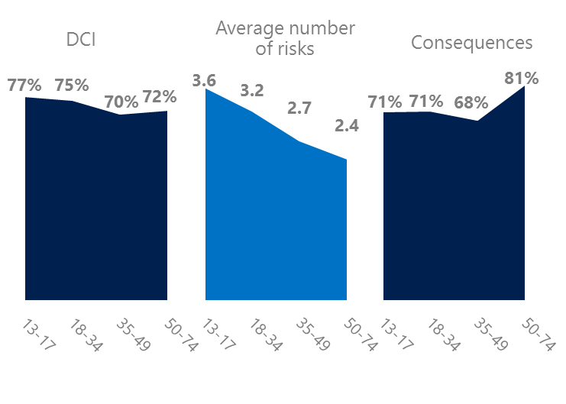4 Teens had the highest levels of risk exposure

Boomers suffered the most consequences

Teenage respondents (ages 13-17) had the highest levels of risk exposure as measured by DCI (77%), average number of risks (3.6) and tied for the second highest level of consequences from risks. 26% of teens were extremely or very concerned about online risks, about the same as other age groups. 15% said they were not treated in a safe or civil manner online which was the highest among all age groups. These high levels of risk exposure coincided with some of the lowest levels of civil behavior online as defined by the Microsoft Digital Civility Challenge, announced in 2017. Teens were less likely to treat others with respect and dignity, respect other people’s point of view or pause before replying to something they disagreed with. Teens were best at standing up for themselves and for other people.

Teens were the least respectful & civil



5 The consequences from harassment were higher for females than males

Over six in 10 respondents experienced one or more forms of harassment. This study defined harassment as Unwanted Contact, Unwanted Sexting, Online Harassment, Cyberbullying or Misogyny. Teens reported higher harassment levels versus adults driven by Online Harassment which was 21 points higher. Females were more likely than males to report Unwanted Contact (44%, 36%) although the overall level of harassment was equal.

Over six in 10 people were harassed

The consequences from online risks affected females at a higher rate than males. Females scored 18 points higher on life became more stressful and directionally higher on the remaining four forms of harassment.

Definitions of online risks

1. **Cyberbullying:** When the Internet, phones or other devices are used to send or post text, images, or video intended to hurt, embarrass or intimidate another person.
2. **Damage to Personal reputation:** Damage or destruction to the image created of you through PERSONAL information you or others shared online in blogs, postings, pictures, tweets, videos, etc.
3. **Damage to Professional/Work reputation:** Damage or destruction to the image created of you through work information you or others shared online in blogs, postings, pictures, tweets, videos, etc.
4. **Discrimination:** A person who is discriminated against or excluded based on gender, ethnic origin, religion, race, disability, or sexual orientation.
5. **Doxxing:** The process of collecting and distributing or posting information about a person (e.g., name, age, email, address, phone number, photographs, etc.) without their permission.
6. **Hate speech:** speech that attacks a person or group based on gender, ethnic origin, religion, race, disability, or sexual orientation.
7. **Hoaxes, scams, frauds:** The spreading of false rumors (e.g., chain letters), criminal attempts to obtain personal information often for monetary gain (e.g., phishing scams), malicious emails disguised as someone you know (e.g. virus).
8. **Microaggression:** Casual insults made towards any marginalized group in society (e.g., religious or ethnic minorities, women, LGBT, people with disabilities, etc.).
9. **Misogyny**: An expression or demonstration of dislike, contempt for, or ingrained prejudice against women.
10. **Online harassment:** Threats or other offensive behavior (not sexual solicitation) sent online or posted online for others to see.
11. **Revenge pornography:** A sexually explicit portrayal of one or more people distributed without their consent.
12. **Sextortion:** When someone threatens to distribute your private and sensitive material if you don’t provide them images of a sexual nature, sexual favors, or money. The perpetrator may also threaten to harm your friends or relatives by using information they have obtained from your electronic devices unless you comply with their demands.
13. **Sexual solicitation:** A person who requests to engage in sexual activities or sexual talk or to give personal sexual information that is unwanted.
14. **Swatting:** The act of deceiving emergency services (e.g., police, fire, medical) into sending an emergency response based on the false report of an ongoing critical incident or crime.
15. **Terrorism recruiting:** An attempt by a terrorist or terrorist organization to recruit a person for the purposes of causing harm.
16. **Treated Mean:** Words or messages sent to another person online that are unkind, unfair or malicious.
17. **Trolling:** A deliberate act to make someone mad or angry using online or social media comments in a clever, but deceitful manner.
18. **Unwanted Sexting Sent:** I sent unwanted sexually explicit messages and imagery.
19. **Unwanted Sexting Received:** Received unwanted sexually explicit messages and imagery.
20. **Unwanted contact:** Being personally contacted (by phone or in person) by someone who obtained your information online but without inviting them to contact you.

1. 9 new countries: Argentina, Colombia, Peru, Hungary, Ireland, Italy, Japan, Malaysia, Vietnam

   14 Wave 1 countries: Australia, Belgium, Brazil, Chile, China, France, Germany, India, Mexico, Russia, South Africa, Turkey, UK, U.S.

   3 new online risks: Hoaxes, Frauds and Scams as one collective risk, Microaggression, Misogyny