Microsoft Digital Civility Index (DCI) 2017 – Mexico



The 2017 Civility, Safety and Interaction Online study examines the extent of negative behaviors and online interactions and their consequences. These results build on last year’s study and were based on interviews with teens ages 13-17 and adults ages 18-74. The scope of research increased to encompass 23 countries and 20 online risks (nine newly included countries, three added risks).[1]

Themes for 2017

DCI improved since 2016

1. 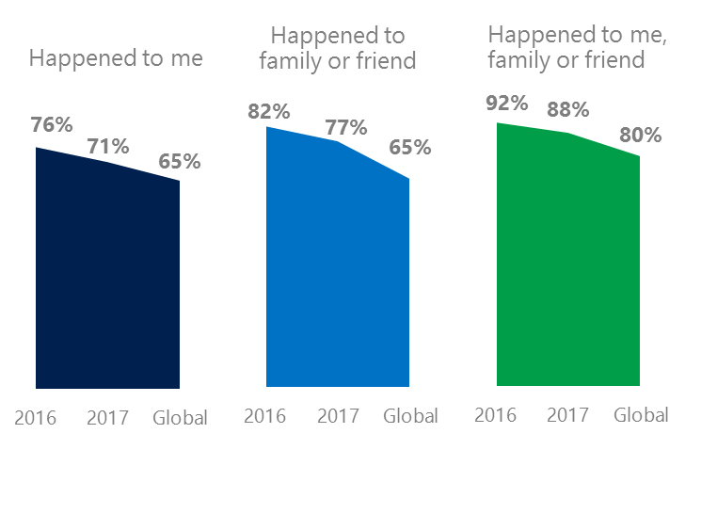The level of online risks fell YOY for respondents and their family and friends since 2016. Mexico experienced risks at rates above the global averages.
2. Targets of online risks often named acquaintances, friends or family as perpetrators.
3. Encouraging signs emerged as people began to evolve their approaches towards the challenges of negative online interactions.
4. Millennials (ages 18-34) had the highest lifetime exposure to online risks while Baby Boomers (ages 50-74) reported the highest level of civil behavior.
5. Consequences from bullying and harassment were higher for females than males.

Reputational risks declined since 2016

1 Mexico DCI was 71%

Mexico ranked 15th out of 23 countries for exposure to online risks with DCI down five points since 2016 – tied with China for the largest YOY decline. In 2017, we maintained and added two risks to the Intrusive category and one risk to Behavioral. Without these changes, DCI would have been 68%.

**Intrusive:** The addition of Hoaxes, Scams & Frauds (31%) and Misogyny (9%) lifted the category up five points YOY. Unwanted Contact (47%) remained the top risk overall, but fell six points since 2016.

**Sexual:** Over four in 10 respondents experienced a Sexual risk down three points since 2016. Unwanted Sexting Received or Sent (37%) remained the top risk down two points YOY and the third highest behind Peru (46%) and Colombia (41%).

**Behavioral:** Behavioral risks were flat YOY and equal to the global average. Being Treated Mean dropped seven points but was unable to drive the category down due to the addition of Microaggression (20%), new in 2017 which was eight points above the global average.

**Reputational:** Reputational risks fell eight points YOY led by a decline in Damage to Personal Reputation (8%, -5 points).

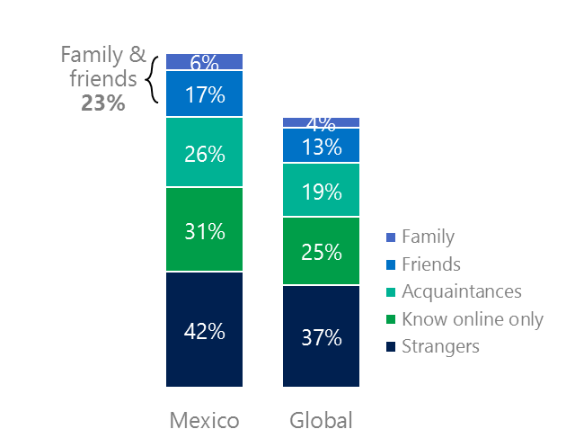2Targets of online risks often named people they knew as perpetrators

23% of perpetrators were family or friends

(among those who said they were treated unsafely or uncivilly)

Although many believe online risks are facilitated by the anonymity provided by the internet, these experiences often involved people they knew personally including family and friends (23%) compared to 17% globally. 61% had met their perpetrator in real life up 13 points from 2016 and eight points higher than the global average (53%). Among those who had met their perpetrator, nearly eight in 10 (77%) met before the risk occurred. Familiarity with the perpetrator in real life was related to an increased exposure to online risks. The average number of risks was 64% higher among those who had met the perpetrator in real life vs. those who had not (5.0 vs. 3.0).

Familiarity with the perpetrator in real life also affected exposure to consequences. Over seven in 10 respondents (71%) suffered at least one consequence from online risks with loss of trust online and offline being the most common. Among those who had met their perpetrator in real life, 56% lost trust in others online and 35% lost trust in others offline. This compared to a lost trust in others online (35%) and offline (24%) for those who had not met the perpetrator in real life.

Loss of trust was the biggest consequence

3 Encouraging signs emerged

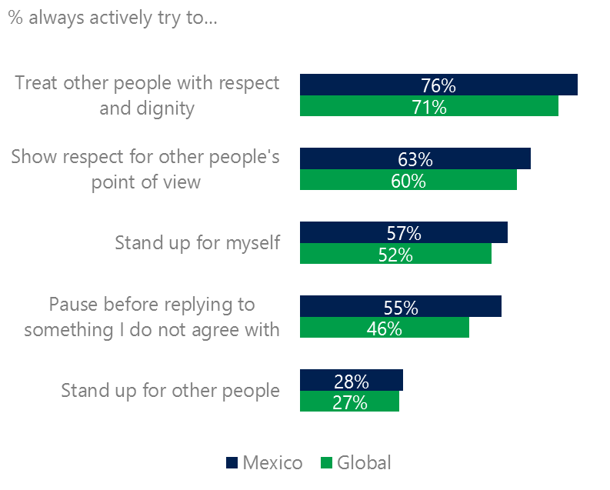Mexico scored above the global averages for civil behavior as defined by the Microsoft Digital Civility Challenge, announced in 2017. They exceeded the averages on most measures with the largest gaps being paused before replying to something I disagree with (55%, +9 points), treated others with respect and dignity (76%, +5 points) and standing up for myself (57%, +5 points).

Reports of civil behavior were widespread

Over half (53%) of respondents said they were extremely or very confident in managing online risks up two points YOY and above the global average (46%). A greater number of respondents knew where to find help if needed (45%, +10 points YOY) which equaled the global average (45%).

Adults were more likely than teens to pause before replying to something they disagreed with (60%, 50%), stand up for themselves (61%, 52%) and show respect for other people’s point of view (66%, 60%).

4 Millennials had the highest exposure to risks and their consequences

Eight in 10 of Millennials suffered a consequence from an online risk

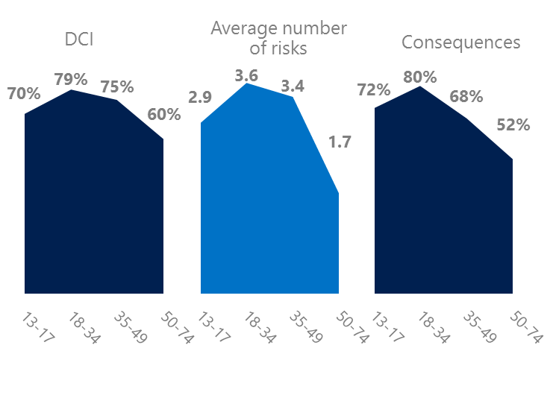Millennial generation respondents (ages 18-34) had the highest levels of risk exposure as measured by DCI (79%), consequences from risks (80%), the average number of risks (3.6). One possible explanation for these high levels is that Millennials were the first generation to grow up in a digital, media-saturated world with abundant free time to explore and experiment. Slightly under half of Millennials (48%) were extremely or very concerned about online risks and 29% said they were not treated in a safe or civil manner online – almost twice the global average (15%).

Conversely, the Baby Boom generation (ages 50-74) had the lowest DCI (60%), average number of risks (1.7) and consequences from risks (52%). More importantly, this age group reported some of the highest levels of civil behavior online as defined by the Microsoft Digital Civility Challenge, announced in 2017. Respondents from Generation X (ages 35-49) and Millennials were the most likely to pause before replying to something they disagreed with and stand up for themselves.

Boomers were the most respectful & civil

5 Harassment was higher for females

Mexico had the eighth highest level of harassment (61%) among the 23 countries surveyed. This study defined harassment as Unwanted Contact, Unwanted Sexting, Online Harassment, Cyberbullying or Misogyny. Overall, females reported higher harassment levels versus males (64%, 58%) driven by Online Harassment, Cyberbullying and Misogyny. Adults reported a higher incidence of Unwanted Sexting than teens while teens scored higher on Cyberbullying than adults.

Over six in 10 people were harassed

Loss of trust was higher among females than males. Females scored 13 points higher on lost trust in people online and five points higher on lost trust in people offline (36%, 31%).

Definitions of online risks

1. **Cyberbullying:** When the Internet, phones or other devices are used to send or post text, images, or video intended to hurt, embarrass or intimidate another person.
2. **Damage to Personal reputation:** Damage or destruction to the image created of you through PERSONAL information you or others shared online in blogs, postings, pictures, tweets, videos, etc.
3. **Damage to Professional/Work reputation:** Damage or destruction to the image created of you through work information you or others shared online in blogs, postings, pictures, tweets, videos, etc.
4. **Discrimination:** A person who is discriminated against or excluded based on gender, ethnic origin, religion, race, disability, or sexual orientation.
5. **Doxxing:** The process of collecting and distributing or posting information about a person (e.g., name, age, email, address, phone number, photographs, etc.) without their permission.
6. **Hate speech:** speech that attacks a person or group based on gender, ethnic origin, religion, race, disability, or sexual orientation.
7. **Hoaxes, scams, frauds:** The spreading of false rumors (e.g., chain letters), criminal attempts to obtain personal information often for monetary gain (e.g., phishing scams), malicious emails disguised as someone you know (e.g. virus).
8. **Microaggression:** Casual insults made towards any marginalized group in society (e.g., religious or ethnic minorities, women, LGBT, people with disabilities, etc.).
9. **Misogyny**: An expression or demonstration of dislike, contempt for, or ingrained prejudice against women.
10. **Online harassment:** Threats or other offensive behavior (not sexual solicitation) sent online or posted online for others to see.
11. **Revenge pornography:** A sexually explicit portrayal of one or more people distributed without their consent.
12. **Sextortion:** When someone threatens to distribute your private and sensitive material if you don’t provide them images of a sexual nature, sexual favors, or money. The perpetrator may also threaten to harm your friends or relatives by using information they have obtained from your electronic devices unless you comply with their demands.
13. **Sexual solicitation:** A person who requests to engage in sexual activities or sexual talk or to give personal sexual information that is unwanted.
14. **Swatting:** The act of deceiving emergency services (e.g., police, fire, medical) into sending an emergency response based on the false report of an ongoing critical incident or crime.
15. **Terrorism recruiting:** An attempt by a terrorist or terrorist organization to recruit a person for the purposes of causing harm.
16. **Treated Mean:** Words or messages sent to another person online that are unkind, unfair or malicious.
17. **Trolling:** A deliberate act to make someone mad or angry using online or social media comments in a clever, but deceitful manner.
18. **Unwanted Sexting Sent:** I sent unwanted sexually explicit messages and imagery.
19. **Unwanted Sexting Received:** Received unwanted sexually explicit messages and imagery.
20. **Unwanted contact:** Being personally contacted (by phone or in person) by someone who obtained your information online but without inviting them to contact you.

1. 9 new countries: Argentina, Colombia, Peru, Hungary, Ireland, Italy, Japan, Malaysia, Vietnam

   14 Wave 1 countries: Australia, Belgium, Brazil, Chile, China, France, Germany, India, Mexico, Russia, South Africa, Turkey, UK, U.S.

   3 new online risks: Hoaxes, Frauds and Scams as one collective risk, Microaggression, Misogyny