Microsoft Digital Civility Index (DCI) 2017 – Malaysia



The 2017 Civility, Safety and Interaction Online study examines the extent of negative behaviors and online interactions and their consequences. These results build on last year’s study and were based on interviews with teens ages 13-17 and adults ages 18-74. The scope of research increased to encompass 23 countries and 20 online risks (nine newly included countries, three added risks).[1]

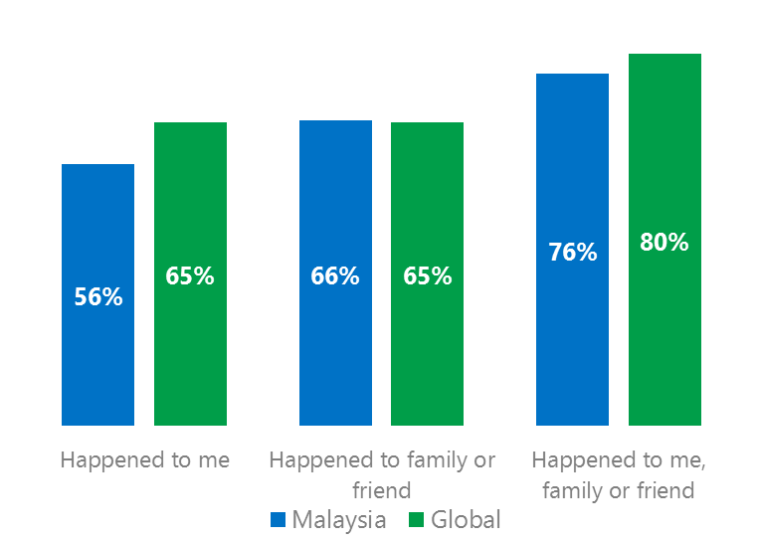Themes for 2017

DCI was below the global average

1. Respondents reported exposure to online risks for themselves below the global average and equal to the global average for family or friends.
2. Targets of online risks often named acquaintances, friends or family as perpetrators.
3. Respondents said they treated other people with dignity and respect but were less likely to stand up for themselves or others or paused before replying to something they disagreed with.
4. Teens (ages 13-17) reported the highest exposure to online risks and their consequences while Millennials (ages 18-34) reported the highest levels of civil behavior.
5. The consequences from bullying and harassment were higher for females and teens than males and adults.



Intrusive risks were below the global average

1. Malaysia DCI was 56%

Malaysia ranked fourth out of 23 countries for exposure to online risks which was nine points lower than the global average. In 2017, we maintained and added two risks to the Intrusive category and one risk to Behavioral. Without these changes, DCI would have been 55%.

**Behavioral:** Over four in 10 reported a Behavioral risk driven by Online Harassment (28%) and Trolling (22%). Online Harassment was 14 points above the global average and the second most common risk overall behind Unwanted Sexting.

**Intrusive:** The category was significantly below the global average led by Hoaxes, Scams & Frauds (20%) and Unwanted Contact (18%), the latter the second lowest score overall after Japan (13%).

**Sexual:** Over one-third had experienced a Sexual risk led by Unwanted Sexting Received or Sent (30%) which was above the global average by five points (25%).

**Reputational:** Slightly under one in five a Reputational risk. All three Reputational risks were in line with the global averages. 2Targets of online risks often named 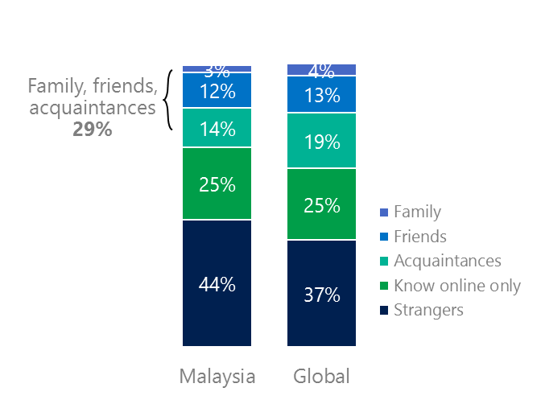people they knew as perpetrators

29% of perpetrators were family, friends or acquaintances

(among those who said they were treated unsafely or uncivilly)

Although many believe online risks are facilitated by the anonymity provided by the internet, these experiences often involved people they knew personally including family, friends or acquaintances (29%) compared to 36% globally. 66% had met their perpetrator in real life which was 13 points higher than the global average (53%). Among those who had met their perpetrator, 77% met before the risk occurred. Familiarity with the perpetrator in real life was related to an increased exposure to online risks. The average number of risks was 47% higher among those who had met the perpetrator in real life vs. those who had not (5.2 vs. 3.5).

Familiarity with the perpetrator in real life also affected exposure to consequences. Nearly three-quarters of respondents (73%, five points over the global average) suffered at least one consequence from online risks with loss of trust online (37%) and loss of sleep (33%) were the most common. Among those who had met their perpetrator in real life, 48% said they lost sleep compared to 25% for those who had not met the perpetrator in real life. Similarly, respondents were twice as likely (44%, 22%) to report becoming depressed if they had met the perpetrator in real life.

Loss of trust was the biggest consequence

3 Most treated other people with dignity & respect

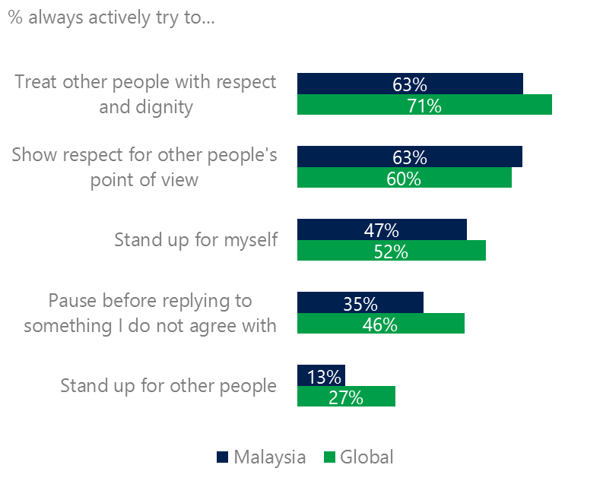Most respondents reported they treated other people with respect and dignity and respected others point of view. Malaysians were less likely to stand up for themselves or others or pausing before replying to something they disagreed with compared with the global averages.

Civil behavior scores met or fell below the global averages

Females were more likely than males to treat other people with respect and dignity (66%, 59%) and were 10 points higher on pausing before replying to something they disagreed with (40%, 30%). Adults were more likely to report high levels of civil behavior than teens.

Only one-third of respondents were confident in their ability to manage online risks compared to the global average (33%, 46%) although 47% knew where to find help if needed compared to 45% globally. Males were more confident than females (37%, 30%) in their ability to manage risks but were equal on finding help if needed 46%, 47%).

4 Teens reported the highest exposure to risks and their consequences

Teens had the highest exposure to the consequences of online risks

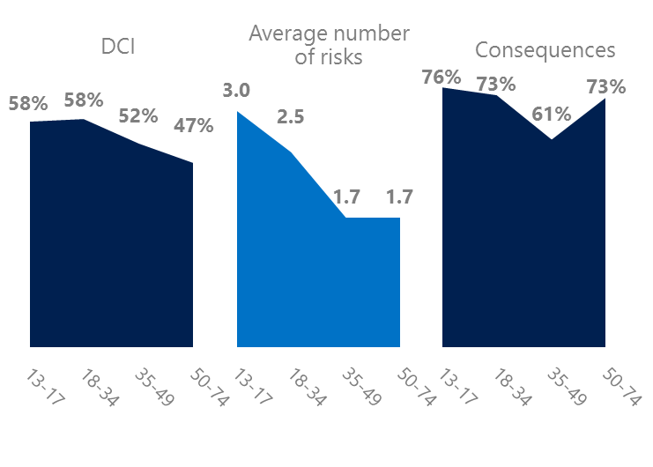Teens scored the highest among all age groups on the average number of risks (3.0) and the consequences from risks (76%) and tied for the highest DCI (58%). They were the least likely to pause before replying to something they disagreed with but the most likely along with Millennials (ages 18-34) to stand up for someone else. High exposure to risks translated into nearly two-thirds (65%) of teens being extremely or very concerned about online risks.

Millennials like teens had high exposure to risks and their consequences. Unlike teens, Millennials reported some of the highest civil behavior as defined by the Microsoft Digital Civility Challenge, announced in 2017.

Millennials were the most respectful & civil

5 Consequences from harassment were more likely to affect females and teens

45% of respondents reported some form of harassment which ranked fifth out of 23 countries and eight points under the global average (54%). This study defined harassment as Unwanted Contact, Unwanted Sexting, Online Harassment, Cyberbullying or Misogyny.

Consequences from most forms of harassment were higher for females and teens than males and adults. Females were 14 points higher than males on less trusting of people offline and 13 points higher on less trusting of people online. Teens scored 19 points higher than adults on became depressed and 17 points higher on life became more stressful.

Over four in 10 people were harassed

Definitions of online risks

1. **Cyberbullying:** When the Internet, phones or other devices are used to send or post text, images, or video intended to hurt, embarrass or intimidate another person.
2. **Damage to Personal reputation:** Damage or destruction to the image created of you through PERSONAL information you or others shared online in blogs, postings, pictures, tweets, videos, etc.
3. **Damage to Professional/Work reputation:** Damage or destruction to the image created of you through work information you or others shared online in blogs, postings, pictures, tweets, videos, etc.
4. **Discrimination:** A person who is discriminated against or excluded based on gender, ethnic origin, religion, race, disability, or sexual orientation.
5. **Doxxing:** The process of collecting and distributing or posting information about a person (e.g., name, age, email, address, phone number, photographs, etc.) without their permission.
6. **Hate speech:** speech that attacks a person or group based on gender, ethnic origin, religion, race, disability, or sexual orientation.
7. **Hoaxes, scams, frauds:** The spreading of false rumors (e.g., chain letters), criminal attempts to obtain personal information often for monetary gain (e.g., phishing scams), malicious emails disguised as someone you know (e.g. virus).
8. **Microaggression:** Casual insults made towards any marginalized group in society (e.g., religious or ethnic minorities, women, LGBT, people with disabilities, etc.).
9. **Misogyny**: An expression or demonstration of dislike, contempt for, or ingrained prejudice against women.
10. **Online harassment:** Threats or other offensive behavior (not sexual solicitation) sent online or posted online for others to see.
11. **Revenge pornography:** A sexually explicit portrayal of one or more people distributed without their consent.
12. **Sextortion:** When someone threatens to distribute your private and sensitive material if you don’t provide them images of a sexual nature, sexual favors, or money. The perpetrator may also threaten to harm your friends or relatives by using information they have obtained from your electronic devices unless you comply with their demands.
13. **Sexual solicitation:** A person who requests to engage in sexual activities or sexual talk or to give personal sexual information that is unwanted.
14. **Swatting:** The act of deceiving emergency services (e.g., police, fire, medical) into sending an emergency response based on the false report of an ongoing critical incident or crime.
15. **Terrorism recruiting:** An attempt by a terrorist or terrorist organization to recruit a person for the purposes of causing harm.
16. **Treated Mean:** Words or messages sent to another person online that are unkind, unfair or malicious.
17. **Trolling:** A deliberate act to make someone mad or angry using online or social media comments in a clever, but deceitful manner.
18. **Unwanted Sexting Sent:** I sent unwanted sexually explicit messages and imagery.
19. **Unwanted Sexting Received:** Received unwanted sexually explicit messages and imagery.
20. **Unwanted contact:** Being personally contacted (by phone or in person) by someone who obtained your information online but without inviting them to contact you.

1. 9 new countries: Argentina, Colombia, Peru, Hungary, Malaysia, Malaysia, Japan, Malaysia, Vietnam

   14 Wave 1 countries: Australia, Belgium, Brazil, Chile, China, France, Germany, India, Mexico, Russia, South Africa, Turkey, UK, U.S.

   3 new online risks: Hoaxes, Frauds and Scams as one collective risk, Microaggression, Misogyny