Microsoft Digital Civility Index (DCI) 2017 – Latam



The 2017 Civility, Safety and Interaction Online study examines the extent of negative behaviors and online interactions and their consequences. These results build on last year’s study and were based on interviews with teens ages 13-17 and adults ages 18-74. The scope of research increased to encompass 23 countries and 20 online risks (nine newly included countries, three added risks).[1] For purposes of this report, Latam included Argentina, Brazil, Chile, Colombia, Mexico and Peru.

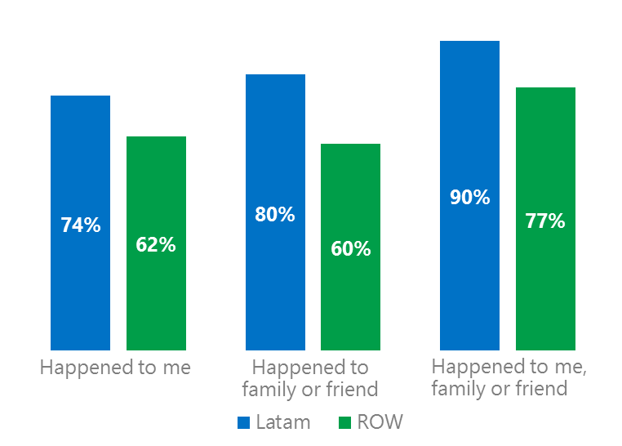Themes for 2017

Risk exposure was above the global averages

1. Latam’s exposure to online risks among individuals, family or friends was significantly higher than the rest of world (ROW)[2] average.
2. Targets of online risks often named acquaintances, friends or family as perpetrators.
3. Encouraging signs emerged as people began to evolve their approaches towards the challenges of negative online interactions.
4. Millennials (ages 18-34) had the highest lifetime exposure to online risks while Baby Boomers (ages 50-74) reported the highest level of civil behavior.
5. Females and adults reported higher rates of harassment than males and teens. The consequences from risks were higher for females than males.



Intrusive risks affected over six in 10 respondents

1Latam DCI was 74%

Latam DCI was 12 points above the ROW average. There was a 20-point gap when risk exposure for family and friends was included. In 2017, we maintained and added two risks to the Intrusive category and one risk to Behavioral. Without these changes, DCI would have been two points lower to 72%.

**Intrusive:** Unwanted Contact (52%) was the most common risk, 14 points above the ROW average. The addition of Hoaxes, Scams & Frauds (28%) and Misogyny (4%) added six points to the category.

**Sexual:** The category was 17 points above the ROW average led by Unwanted Sexting Received or Sent (35%) and Sexual Solicitation (23%). Unlike most countries, Chile, Colombia, Mexico and Peru placed the category second, ahead of Behavioral risks.

**Behavioral:** Behavioral risks were generally in line with the ROW averages led being Treated Mean (22%). which was the third highest risk in Latam and was four points above the global average. Trolling was the exception scoring four points under the ROW average.

**Reputational:** Slightly under one in five respondents suffered a Reputational risk. Damage to Personal Reputation (10%) was the most common risk.2Targets of online risks often named 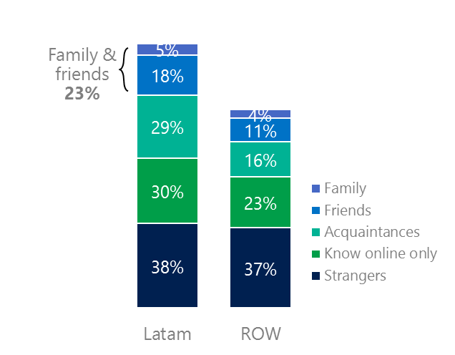people they knew as perpetrators

23% of perpetrators were family or friends

(among those who said they were treated unsafely or uncivilly)

Although many believe online risks are facilitated by the anonymity provided by the internet, these experiences often involved people they knew personally including family and friends (23%) compared to 15% ROW. 60% had met their perpetrator in real life which was 10 points less than the ROW average (50%). Among those who had met their perpetrator, 73% met before the risk occurred four points lower than the ROW average. Familiarity with the perpetrator in real life was related to an increased exposure to online risks. The average number of risks was 63% higher among those who had met the perpetrator in real life vs. those who had not (4.8 vs. 2.9).

Familiarity with the perpetrator in real life also affected exposure to consequences. Nearly seven in 10 respondents (68%) suffered at least one negative consequence from online risks with loss of trust online and offline being the most common. Among those who had met their perpetrator in real life, 54% lost trust in others online and 39% lost trust in others offline. This compared to a loss of trust online (36%) and offline (23%) for those who had not met the perpetrator in real life.

Loss of trust was the biggest consequence

3 Encouraging signs emerged

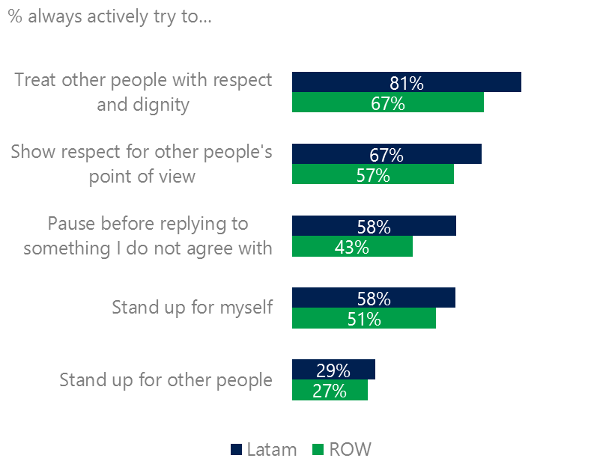Latam had the highest scores for civil behavior as defined by the Microsoft Digital Civility Challenge, announced in 2017. High numbers of respondents stated that they actively tried to treat others with respect and dignity (81%, 67%), showed respect to other’s point of view (67%, 57%), paused before replying to someone they disagreed with (58%, 43%) and stood up for themselves (58%, 51%).

Intentions of civil behavior were highest in Latam

53% of respondents said they were extremely or very confident in managing online risks compared to 43% ROW and more people knew where to find help if needed (52%, 42%).

Females were more likely than males to treat others with respect and dignity (82%, 79%) and to pause before replying to someone they disagreed with (61%, 55%). Adults were more likely than teens to pause before replying to someone they disagreed with (63%, 52%).

4 Millennials had the highest lifetime exposure to risks & their consequences

Nearly eight in 10 Millennials experienced a consequence from online risks

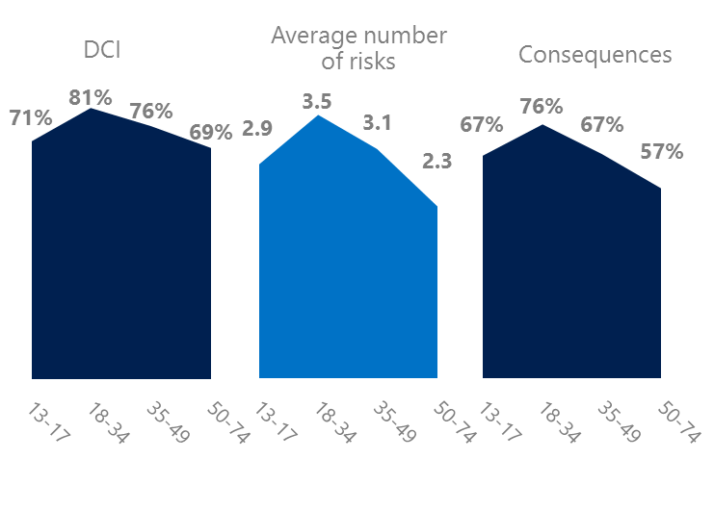Millennial generation respondents (ages 18-34) had the highest levels of risk exposure as measured by DCI (81%), average number of risks (3.5) and consequences from risks (76%). One possible explanation for these high levels is that Millennials were the first generation to grow up in a digital, media-saturated world with abundant free time to explore and experiment. One quarter of Millennials said they were not treated in a safe or civil manner online, highest among all age groups. Not surprisingly, over four in 10 Millennials (43%) were extremely or very concerned about online risks compared to 36% ROW.

Conversely, the Baby Boom generation (ages 50-74) had the lowest DCI (69%), average number of risks (2.3) and consequences from risks (57%) and concerns about online risks (36%). More importantly, this age group reported some of the highest levels of civil behavior online as defined by the Microsoft Digital Civility Challenge, announced in 2017. They were more likely to treat others with respect and dignity and to be thoughtful in online exchanges when people disagreed.

Boomers were the most respectful & civil

5 Harassment and their consequences were more likely to affect females

Over six in 10 respondents experienced harassment, 14 points above the ROW average. This study defined harassment as Unwanted Contact, Unwanted Sexting, Online Harassment, Cyberbullying or Misogyny. Females reported higher rates of harassment than males led by Online Harassment (18%, 8%) and Unwanted Contact (54%, 50%). Adults reported higher rates of harassment than teens driven by Unwanted Sexting (39%, 31%).

Over six in 10 people were harassed

The consequences from harassment were higher for females than males. Females were 17 points higher than males on lost trust in people offline and 11 points higher on lost trust in people online. Consequences from online risks were similar for adults and teens.

Definitions of online risks

1. **Cyberbullying:** When the Internet, phones or other devices are used to send or post text, images, or video intended to hurt, embarrass or intimidate another person.
2. **Damage to Personal reputation:** Damage or destruction to the image created of you through PERSONAL information you or others shared online in blogs, postings, pictures, tweets, videos, etc.
3. **Damage to Professional/Work reputation:** Damage or destruction to the image created of you through work information you or others shared online in blogs, postings, pictures, tweets, videos, etc.
4. **Discrimination:** A person who is discriminated against or excluded based on gender, ethnic origin, religion, race, disability, or sexual orientation.
5. **Doxxing:** The process of collecting and distributing or posting information about a person (e.g., name, age, email, address, phone number, photographs, etc.) without their permission.
6. **Hate speech:** speech that attacks a person or group based on gender, ethnic origin, religion, race, disability, or sexual orientation.
7. **Hoaxes, scams, frauds:** The spreading of false rumors (e.g., chain letters), criminal attempts to obtain personal information often for monetary gain (e.g., phishing scams), malicious emails disguised as someone you know (e.g. virus).
8. **Microaggression:** Casual insults made towards any marginalized group in society (e.g., religious or ethnic minorities, women, LGBT, people with disabilities, etc.).
9. **Misogyny**: An expression or demonstration of dislike, contempt for, or ingrained prejudice against women.
10. **Online harassment:** Threats or other offensive behavior (not sexual solicitation) sent online or posted online for others to see.
11. **Revenge pornography:** A sexually explicit portrayal of one or more people distributed without their consent.
12. **Sextortion:** When someone threatens to distribute your private and sensitive material if you don’t provide them images of a sexual nature, sexual favors, or money. The perpetrator may also threaten to harm your friends or relatives by using information they have obtained from your electronic devices unless you comply with their demands.
13. **Sexual solicitation:** A person who requests to engage in sexual activities or sexual talk or to give personal sexual information that is unwanted.
14. **Swatting:** The act of deceiving emergency services (e.g., police, fire, medical) into sending an emergency response based on the false report of an ongoing critical incident or crime.
15. **Terrorism recruiting:** An attempt by a terrorist or terrorist organization to recruit a person for the purposes of causing harm.
16. **Treated Mean:** Words or messages sent to another person online that are unkind, unfair or malicious.
17. **Trolling:** A deliberate act to make someone mad or angry using online or social media comments in a clever, but deceitful manner.
18. **Unwanted Sexting Sent:** I sent unwanted sexually explicit messages and imagery.
19. **Unwanted Sexting Received:** Received unwanted sexually explicit messages and imagery.
20. **Unwanted contact:** Being personally contacted (by phone or in person) by someone who obtained your information online but without inviting them to contact you.

1. 9 new countries: Argentina, Colombia, Peru, Hungary, Ireland, Italy, Japan, Malaysia, Vietnam

   14 Wave 1 countries: Australia, Belgium, Brazil, Chile, China, France, Germany, India, Mexico, Russia, South Africa, Turkey, UK, U.S.

   3 new online risks: Hoaxes, Frauds and Scams as one collective risk, Microaggression, Misogyny
2. ROW countries: Australia, Belgium, Brazil, China, France, Germany, Hungary, India, Ireland, Italy, Japan, Russia, South Africa, Turkey, U.K, U.S.