Microsoft Digital Civility Index (DCI) 2017 – Japan



The 2017 Civility, Safety and Interaction Online study examines the extent of negative behaviors and online interactions and their consequences. These results build on last year’s study and were based on interviews with teens ages 13-17 and adults ages 18-74. The scope of research increased to encompass 23 countries and 20 online risks (nine newly included countries, three added risks).[1]

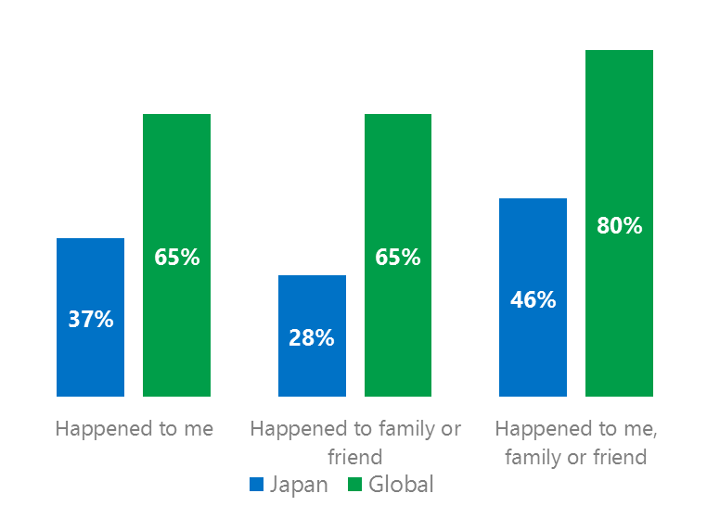Themes for 2017

Risk exposure below the global averages

1. Respondents reported the lowest exposure to online risks and their consequences for themselves, family or friends among all countries surveyed.
2. Targets of online risks often named acquaintances, friends or family as perpetrators.
3. Levels of civil behavior were comparatively low as defined by the Microsoft Civility Challenge. Cultural influences and the way respondents used survey scales make geographic comparisons difficult.
4. The Millennials generation (ages 18-34) had the highest exposure to online risks and reported the lowest levels of civil behavior.
5. The consequences from bullying and harassment were higher for females than males.



Behavioral & Sexual risks under global averages

1Japan DCI was 37%

Japan ranked first out of 23 countries for exposure to online risks which was 28 points lower than the global average. In 2017, we maintained and added two risks to the Intrusive category and one risk to Behavioral. Without these changes, DCI would have been 35%.

**Intrusive:** One in four respondents reported an Intrusive risk led by Unwanted Contact (13%) and Hoaxes, Scams & Frauds (13%). These risks ranked as the second and third highest overall and were significantly below the global averages.

**Sexual:** Nearly one in five respondents experienced a Sexual risk led by Unwanted Sexting Received or Sent (15%) which was the most common risk overall. Like all other risk categories, most Sexual risks were below the global average.

**Behavioral:** Slightly under one in five respondents reported a Behavioral risk. Being Treated Mean, Online Harassment and Trolling were the top three risks - all below the global average.

**Reputational:** Less than one in 10 respondents reported a Reputational risk. All Reputational risks were not statistically different from the global averages. 2Targets of online risks often named 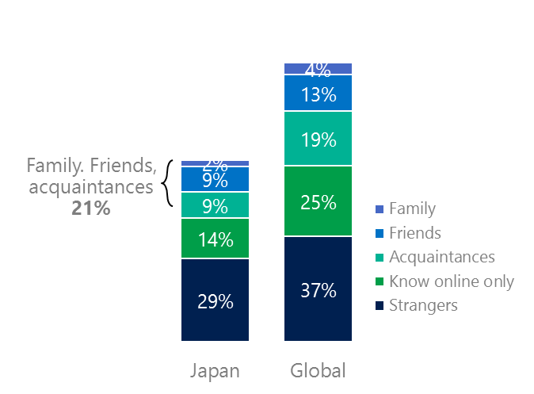people they knew as perpetrators

21% of perpetrators were family, friends or acquaintances

(among those who said they were treated unsafely or uncivilly)

Although many believe online risks are facilitated by the anonymity provided by the internet, these experiences often involved people they knew personally including family, friends or acquaintances (21%), the lowest of all countries slightly ahead of France (23%) and Vietnam (23%). Nearly three in 10 (29%) had met their perpetrator in real life which 24 points under the global average (53%). Among those who had met their perpetrator, 58% met before the risk occurred which was the lowest among countries surveyed. Familiarity with the perpetrator in real life was related to an increased exposure to online risks. The average number of risks was 56% higher among those who had met the perpetrator in real life vs. those who had not (3.9 vs. 2.5).

Familiarity with the perpetrator in real life also affected exposure to consequences. Two-thirds of respondents (61%, seven points under the global average) suffered at least one consequence from online risks with became depressed and life became more stressful were the most common. Among those who had met their perpetrator in real life, 57% became depressed and 42% said life became more stressful. Among those who had not met the perpetrator in real life, became depressed was 19 points lower (38%) and life became more stressful was 15 points lower (27%).

Depression was the biggest consequence

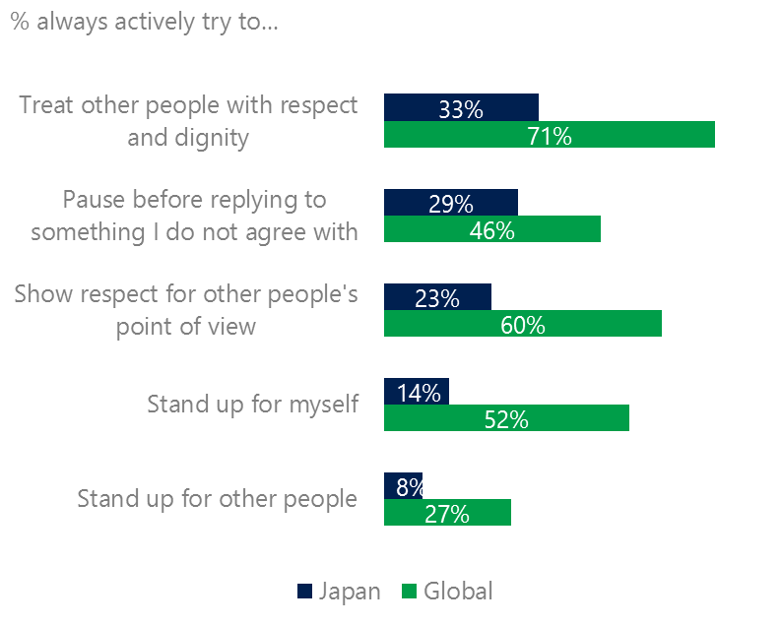3 Below average civil behavior reported Respondents fell significantly below the global averages for civil behavior as defined by the Microsoft Digital Civility Challenge, announced in 2017. These results may be due to cultural factors that manifest themselves in a mild response style where less extreme scale points are preferred over the extremes – a known phenomenon in Japan based surveys. The collectivist nature of Asian cultures (vs. individualist) might help explain the low scores on standing up for oneself and standing up for other people. Similarly, China and Malaysia had low scores on these items. Always treating others with respect and dignity improved 11 points among respondents who experienced a risk more recently (past month) vs. more than a month (40% vs. 29%).

Civil behaviors were under the global averages

Only 11% of respondents reported being extremely or very confident in managing online risks (global average: 46%). Respondents said they did not know where to find help if needed (38%) and 43% were unsure where to find help compared to 25% and 30% globally. Low online risk exposure and a mild response style may help explain these results.

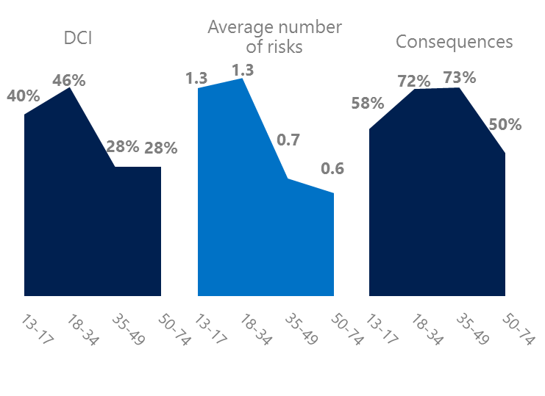4 Millennials reported the highest lifetime online risk exposure

Millennials had the highest lifetime exposure online risks

The Millennial generation (ages 18-34) had the highest DCI (46%) and tied for the highest average number of risks (1.3) and number of consequences from risks (72%). Millennials reported the lowest levels of civil behavior as defined by the Microsoft Digital Civility Challenge, announced in 2017. They were the least likely of all age groups to treat others with respect and dignity, show respect for other people’s point of view and pause before replying to something they disagreed with.

Over seven in 10 Millennials said they experienced a consequence from an online risk. Nearly one-third (32%) were extremely or very concerned about online risks, highest among all age groups. 36% said that Doxxing was the most concerning risk.

Millennials were the least respectful & civil

5 Consequences from harassment were more severe for females

27% of respondents reported some form of harassment which ranked first out of 23 countries and 27 points under the global average (54%). This study defined harassment as Unwanted Contact, Unwanted Sexting, Online Harassment, Cyberbullying or Misogyny. Unwanted Sexting and Unwanted Contact were the most common forms of harassment for both genders and adults and teens.

Consequences from all forms of harassment were higher for females than males. Females scored 23 points higher on became depressed, were twice as likely to lose trust people online, 14 points higher on life became more stressful and 14 points higher on lost trust in people offline.

27% of respondents were harassed

Definitions of online risks

1. **Cyberbullying:** When the Internet, phones or other devices are used to send or post text, images, or video intended to hurt, embarrass or intimidate another person.
2. **Damage to Personal reputation:** Damage or destruction to the image created of you through PERSONAL information you or others shared online in blogs, postings, pictures, tweets, videos, etc.
3. **Damage to Professional/Work reputation:** Damage or destruction to the image created of you through work information you or others shared online in blogs, postings, pictures, tweets, videos, etc.
4. **Discrimination:** A person who is discriminated against or excluded based on gender, ethnic origin, religion, race, disability, or sexual orientation.
5. **Doxxing:** The process of collecting and distributing or posting information about a person (e.g., name, age, email, address, phone number, photographs, etc.) without their permission.
6. **Hate speech:** speech that attacks a person or group based on gender, ethnic origin, religion, race, disability, or sexual orientation.
7. **Hoaxes, scams, frauds:** The spreading of false rumors (e.g., chain letters), criminal attempts to obtain personal information often for monetary gain (e.g., phishing scams), malicious emails disguised as someone you know (e.g. virus).
8. **Microaggression:** Casual insults made towards any marginalized group in society (e.g., religious or ethnic minorities, women, LGBT, people with disabilities, etc.).
9. **Misogyny**: An expression or demonstration of dislike, contempt for, or ingrained prejudice against women.
10. **Online harassment:** Threats or other offensive behavior (not sexual solicitation) sent online or posted online for others to see.
11. **Revenge pornography:** A sexually explicit portrayal of one or more people distributed without their consent.
12. **Sextortion:** When someone threatens to distribute your private and sensitive material if you don’t provide them images of a sexual nature, sexual favors, or money. The perpetrator may also threaten to harm your friends or relatives by using information they have obtained from your electronic devices unless you comply with their demands.
13. **Sexual solicitation:** A person who requests to engage in sexual activities or sexual talk or to give personal sexual information that is unwanted.
14. **Swatting:** The act of deceiving emergency services (e.g., police, fire, medical) into sending an emergency response based on the false report of an ongoing critical incident or crime.
15. **Terrorism recruiting:** An attempt by a terrorist or terrorist organization to recruit a person for the purposes of causing harm.
16. **Treated Mean:** Words or messages sent to another person online that are unkind, unfair or malicious.
17. **Trolling:** A deliberate act to make someone mad or angry using online or social media comments in a clever, but deceitful manner.
18. **Unwanted Sexting Sent:** I sent unwanted sexually explicit messages and imagery.
19. **Unwanted Sexting Received:** Received unwanted sexually explicit messages and imagery.
20. **Unwanted contact:** Being personally contacted (by phone or in person) by someone who obtained your information online but without inviting them to contact you.

1. 9 new countries: Argentina, Colombia, Peru, Hungary, Japan, Japan, Japan, Malaysia, Vietnam

   14 Wave 1 countries: Australia, Belgium, Brazil, Chile, China, France, Germany, India, Mexico, Russia, South Africa, Turkey, UK, U.S.

   3 new online risks: Hoaxes, Frauds and Scams as one collective risk, Microaggression, Misogyny