Microsoft Digital Civility Index (DCI) 2017 – Italy



The 2017 Civility, Safety and Interaction Online study examines the extent of negative behaviors and online interactions and their consequences. These results build on last year’s study and were based on interviews with teens ages 13-17 and adults ages 18-74. The scope of research increased to encompass 23 countries and 20 online risks (nine newly included countries, three added risks).[1]

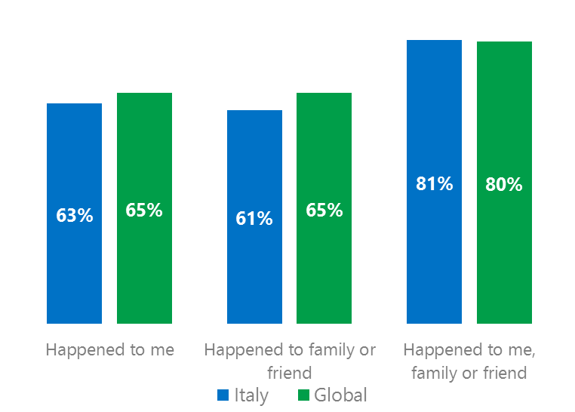Themes for 2017

Risk exposure slightly below the global averages

1. Respondents reported exposure to online risks for themselves, family or friends at levels equal to the global averages.
2. Targets of online risks often named acquaintances, friends or family as perpetrators.
3. Encouraging signs emerged as people began to evolve their approaches towards the challenges of negative online interactions.
4. Baby Boomers (ages 50-74) reported the fewest consequences from online risks and the highest level of civil behavior.
5. The consequences from bullying and harassment were higher for females and teens than males and adults.



Behavioral & Sexual risks under global averages

1Italy DCI was 63%

Italy ranked 10th out of 23 countries for exposure to online risks which was two points lower than the global average. In 2017, we maintained and added two risks to the Intrusive category and one risk to Behavioral. Without these changes, DCI would have been 58%.

**Intrusive:** Nearly six in 10 respondents reported an Intrusive risk led by Unwanted Contact (45%). Hoaxes, Scams & Frauds (28%) ranked second highest among all risks and was similar to the global average.

**Behavioral:** Being Treated Mean, Online Harassment and Microaggression combined to help push the Behavioral category 13 points below the global average.

**Sexual:** Over one in five had experienced a Sexual risk led by Unwanted Sexting Received or Sent (18%) and Sexual Solicitation. Together, these risks drove the category below the global average by nine points.

**Reputational:** Less than two in 10 reported a Reputational risk. The level of Doxxing was in line with the global average and the fifth most common risk overall. 2Targets of online risks often named 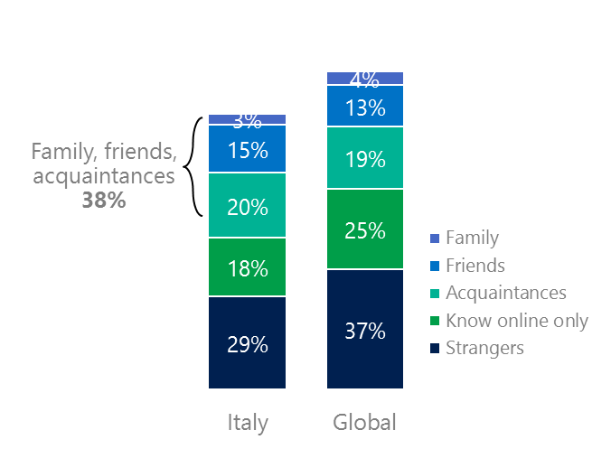people they knew as perpetrators

38% of perpetrators were family, friends or acquaintances

(among those who said they were treated unsafely or uncivilly)

Although many believe online risks are facilitated by the anonymity provided by the internet, these experiences often involved people they knew personally including family, friends or acquaintances (38%) compared to 36% globally. 40% had met their perpetrator in real life which was 13 points less than the global average (53%). Among those who had met their perpetrator, 69% met before the risk occurred which was the fifth lowest among countries surveyed. Familiarity with the perpetrator in real life was related to an increased exposure to online risks. The average number of risks was 68% higher among those who had met the perpetrator in real life vs. those who had not (4.2 vs. 2.5).

Familiarity with the perpetrator in real life also affected exposure to consequences. Two-thirds of respondents (67%, 1 point under the global average) suffered at least one negative consequence from online risks with lost trust in people online and reduced participation in social media, blogs, and forums the most common. Among those who had met their perpetrator in real life, 56% lost trust in people online and 33% said they reduced their participation in social media, blogs and forums. This compared to lost trust in people online (42%) and reduced participation in social media, blogs, and forums (22%) for those who had not met the perpetrator in real life.

Loss of trust was the biggest consequence

3 Encouraging signs emerged

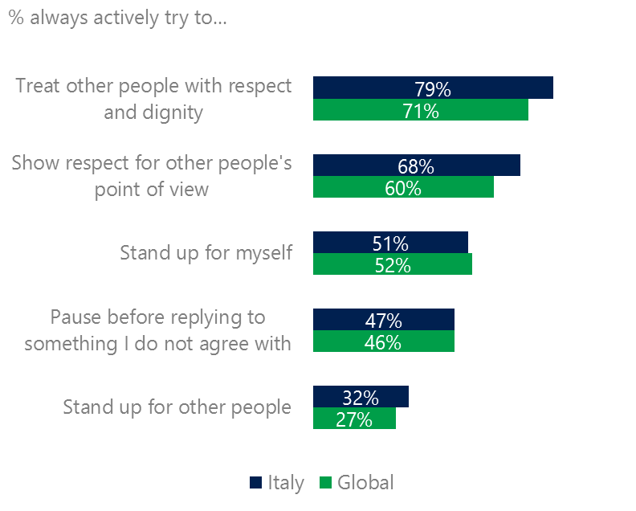Italy exceeded or equaled the global averages for civil behavior as defined by the Microsoft Digital Civility Challenge, announced in 2017. Italy exceeded the global averages for treating others with respect and dignity (79%, 71%) and respected other people’s point of view (68%, 60%).

Reports of civil behavior were widespread

39% of respondents said they were extremely or very confident in managing online risks compared to 46% globally and 64% knew where to find help if needed 19 points above global average (45%).

Adults were more likely than teens (ages 13-17) to pause before replying to something they disagreed with (54%, 39%) and stand up myself (59%, 44%).

4 Baby Boomers reported the fewest consequences from online risks

Teens had the highest exposure to the consequences of online risks

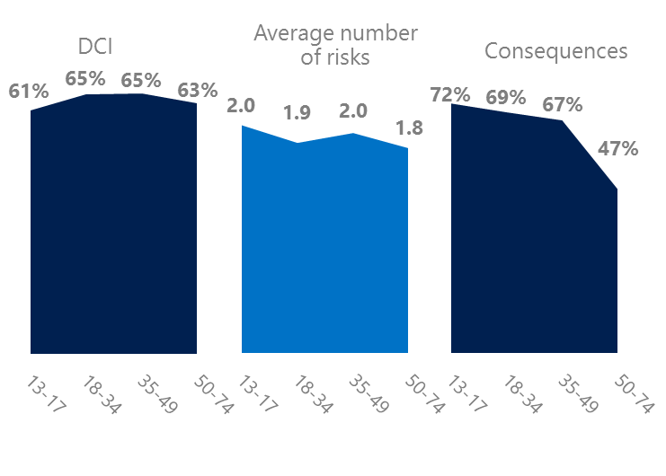The Baby Boom generation (ages 50-74) had the lowest consequences from risks (47%), average number of risks (1.8) and tied for the second lowest DCI (63%). They had higher levels of civil behaviors compared to other age groups except for standing up for myself.

Over seven in 10 Teens said there was a serious consequence from an online risk. Teens were tied for the highest average number of risks but had a slightly lower lifetime exposure to risks presumably due to age. Over one-third of Teens (35%) were extremely or very concerned about online risks, second highest among all age groups.

Boomers were the most respectful & civil

5 Consequences from harassment were more likely to affect females and teens

53% of respondents reported some form of harassment which ranked 12th out of 23 countries and a point under the global average (54%). This study defined harassment as Unwanted Contact, Unwanted Sexting, Online Harassment, Cyberbullying or Misogyny. Overall, females reported higher levels of harassment than males while adults reported more harassment than teens.

Consequences from most forms of harassment were higher for females and teens than males and adults. Females were eight points higher than males on less trusting of people online and seven points higher on life became more stressful. Teens scored eight points higher than adults on life became more stressful and five points higher on less trusting of people offline.

Over five in 10 people were harassed

Definitions of online risks

1. **Cyberbullying:** When the Internet, phones or other devices are used to send or post text, images, or video intended to hurt, embarrass or intimidate another person.
2. **Damage to Personal reputation:** Damage or destruction to the image created of you through PERSONAL information you or others shared online in blogs, postings, pictures, tweets, videos, etc.
3. **Damage to Professional/Work reputation:** Damage or destruction to the image created of you through work information you or others shared online in blogs, postings, pictures, tweets, videos, etc.
4. **Discrimination:** A person who is discriminated against or excluded based on gender, ethnic origin, religion, race, disability, or sexual orientation.
5. **Doxxing:** The process of collecting and distributing or posting information about a person (e.g., name, age, email, address, phone number, photographs, etc.) without their permission.
6. **Hate speech:** speech that attacks a person or group based on gender, ethnic origin, religion, race, disability, or sexual orientation.
7. **Hoaxes, scams, frauds:** The spreading of false rumors (e.g., chain letters), criminal attempts to obtain personal information often for monetary gain (e.g., phishing scams), malicious emails disguised as someone you know (e.g. virus).
8. **Microaggression:** Casual insults made towards any marginalized group in society (e.g., religious or ethnic minorities, women, LGBT, people with disabilities, etc.).
9. **Misogyny**: An expression or demonstration of dislike, contempt for, or ingrained prejudice against women.
10. **Online harassment:** Threats or other offensive behavior (not sexual solicitation) sent online or posted online for others to see.
11. **Revenge pornography:** A sexually explicit portrayal of one or more people distributed without their consent.
12. **Sextortion:** When someone threatens to distribute your private and sensitive material if you don’t provide them images of a sexual nature, sexual favors, or money. The perpetrator may also threaten to harm your friends or relatives by using information they have obtained from your electronic devices unless you comply with their demands.
13. **Sexual solicitation:** A person who requests to engage in sexual activities or sexual talk or to give personal sexual information that is unwanted.
14. **Swatting:** The act of deceiving emergency services (e.g., police, fire, medical) into sending an emergency response based on the false report of an ongoing critical incident or crime.
15. **Terrorism recruiting:** An attempt by a terrorist or terrorist organization to recruit a person for the purposes of causing harm.
16. **Treated Mean:** Words or messages sent to another person online that are unkind, unfair or malicious.
17. **Trolling:** A deliberate act to make someone mad or angry using online or social media comments in a clever, but deceitful manner.
18. **Unwanted Sexting Sent:** I sent unwanted sexually explicit messages and imagery.
19. **Unwanted Sexting Received:** Received unwanted sexually explicit messages and imagery.
20. **Unwanted contact:** Being personally contacted (by phone or in person) by someone who obtained your information online but without inviting them to contact you.

1. 9 new countries: Argentina, Colombia, Peru, Hungary, Italy, Italy, Japan, Malaysia, Vietnam

   14 Wave 1 countries: Italy, Belgium, Brazil, Chile, China, France, Germany, India, Mexico, Russia, South Africa, Turkey, UK, U.S.

   3 new online risks: Hoaxes, Frauds and Scams as one collective risk, Microaggression, Misogyny