Microsoft Digital Civility Index (DCI) 2017 – Ireland



The 2017 Civility, Safety and Interaction Online study examines the extent of negative behaviors and online interactions and their consequences. These results build on last year’s study and were based on interviews with teens ages 13-17 and adults ages 18-74. The scope of research increased to encompass 23 countries and 20 online risks (nine newly included countries, three added risks).[1]

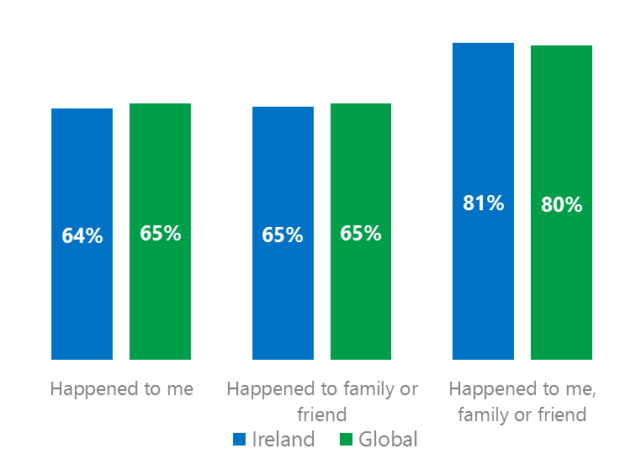Themes for 2017

Risk exposure below the global averages

1. Respondents reported exposure to online risks for themselves, family or friends at levels equal to the global averages.
2. Targets of online risks often named acquaintances, friends or family as perpetrators.
3. Encouraging signs emerged as people began to evolve their approaches towards the challenges of negative online interactions.
4. Millennials (ages 18-34) had the highest lifetime exposure to online risks while Baby Boomers (ages 50-74) reported the highest level of civil behavior.
5. The consequences from bullying and harassment were higher for females and teens than males and adults.

Sexual risks fell below the global averages



1Ireland DCI was 64%

Ireland ranked 11th out of 23 countries for exposure to online risks which was a point lower than the global average. In 2017, we maintained and added two risks to the Intrusive category and one risk to Behavioral. Without these changes, DCI would have been 61%.

**Intrusive:** Over half of respondents reported an Intrusive risk led by Unwanted Contact (40%). Hoaxes, Scams & Frauds (28%) ranked third highest among all risks and was similar to the global average.

**Behavioral:** Four in 10 experienced a Behavioral risk driven by being Treated Mean which was eight points higher than the global average. Treated Mean ranked second highest among all risks.

**Sexual:** Over one in five had experienced a Sexual risk led by Unwanted Sexting Received or Sent (18%) and Sexual Solicitation. Together, these risks drove the category below the global average by nine points.

**Reputational:** Doxxing was the most common reputational risk and equal to the global average. 2Targets of online risks often named 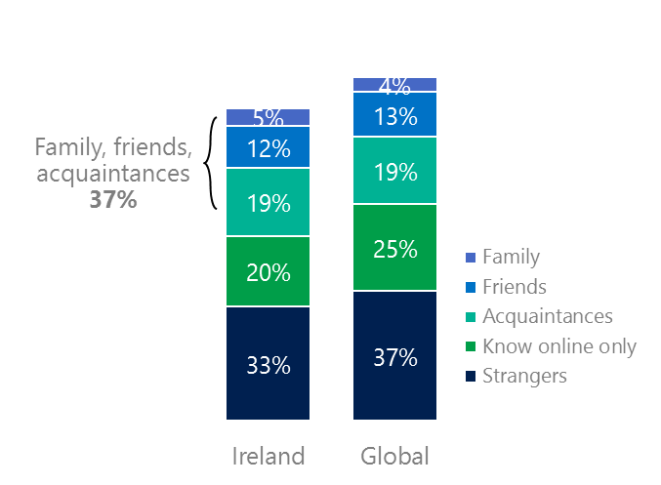people they knew as perpetrators

37% of perpetrators were family, friends or acquaintances

(among those who said they were treated unsafely or uncivilly)

Although many believe online risks are facilitated by the anonymity provided by the internet, these experiences often involved people they knew personally including family, friends or acquaintances (37%) compared to 36% globally. 44% had met their perpetrator in real life which was nine points less than the global average (53%). Among those who had met their perpetrator, 85% met before the risk occurred behind only the UK (94%) and Australia (90%). Familiarity with the perpetrator in real life was related to an increased exposure to online risks. The average number of risks was 86% higher among those who had met the perpetrator in real life vs. those who had not (5.2 vs. 2.8).

Familiarity with the perpetrator in real life also affected exposure to consequences. Over six in 10 respondents (63%, 5 points under the global average) suffered at least one consequence from online risks with lost trust in people online and life became more stressful were most common. Among those who had met their perpetrator in real life, 49% lost trust in people online and 48% said life became more stressful. This compared to loss of trust in people online (36%) and life became more stressful (21%) for those who had not met the perpetrator in real life.

Loss of trust was the biggest consequence

3 Encouraging signs emerged

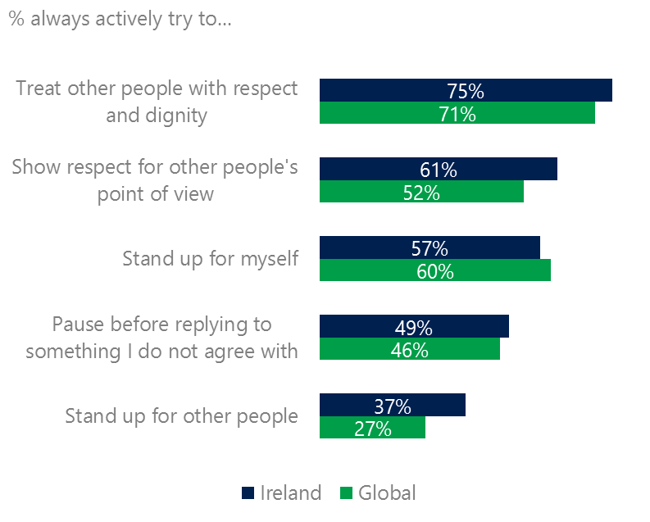Ireland exceeded or equaled the global averages for civil behavior as defined by the Microsoft Digital Civility Challenge, announced in 2017. Three in four respondents stated that they actively tried to treat others with respect and dignity (75%, 71%), respected other people’s point of view (61%, 52%) and stood up for other people (37%, 27%).

Reports of civil behavior were widespread

54% of respondents said they were extremely or very confident in managing online risks compared to 46% globally and 42% knew where to find help if needed slightly under the global average (45%).

Females led males on civil behavior including treating others with respect and dignity (78%, 73%), respecting other people’s point of view (66%, 57%), pausing before replying to something they disagreed with (54%, 43%). Males scored higher on standing up myself (61%, 53%).

4 Millennials had the highest lifetime risk exposure

Millennials had the highest exposure to online risks and their consequences

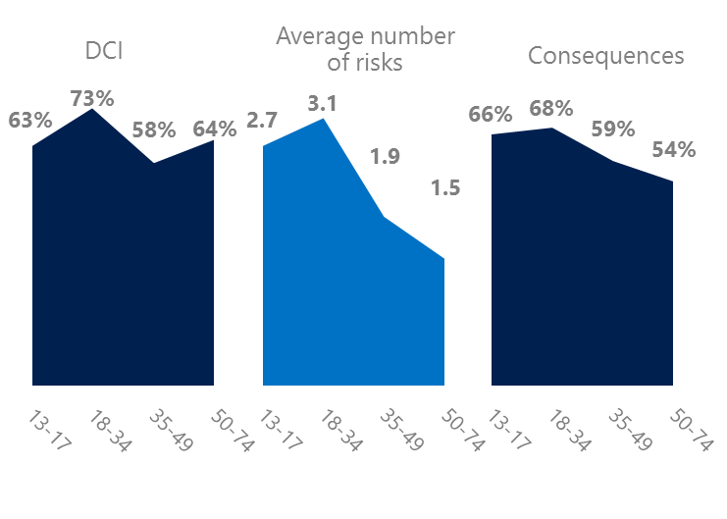Millennial generation respondents (ages 18-34) had the highest levels of risk exposure as measured by DCI (73%) consequences from risks (68%) and average number of risks (3.1). One possible explanation for these high levels is that Millennials were the first generation to grow up in a digital, media-saturated world with abundant free time to explore and experiment. Nearly half (47%) of respondents were extremely or very concerned about online risks, the highest among all age groups.

Conversely, the Baby Boom generation (ages 50-74) had the lowest average number of risks (1.5), consequences from risks (54%) and the second lowest DCI (64%). More importantly, this age group reported some of the highest levels of civil behavior online as defined by the Microsoft Digital Civility Challenge, announced in 2017. They had higher levels of civil behaviors compared to other age groups with the exception of standing up for other people.

Boomers were the most respectful & civil

5 Consequences from harassment were more likely to affect females and teens

Half of respondents reported some form of harassment which ranked 10th out of 23 countries and slightly under the global average (54%). This study defined harassment as Unwanted Contact, Unwanted Sexting, Online Harassment, Cyberbullying or Misogyny. Females reported higher levels of harassment than males while adults reported more Unwanted Contact than teens (ages 13-17).

Five in 10 people were harassed

The severity of consequences from most forms of harassment was higher for females and teens than males and adults. Females were 11 points higher than males on life became more stressful and seven points higher on became depressed. Teens scored 15 points higher than adults on life became more stressful, 14 points higher on had thoughts of suicide and 10 points higher on less trusting of people offline.

Definitions of online risks

1. **Cyberbullying:** When the Internet, phones or other devices are used to send or post text, images, or video intended to hurt, embarrass or intimidate another person.
2. **Damage to Personal reputation:** Damage or destruction to the image created of you through PERSONAL information you or others shared online in blogs, postings, pictures, tweets, videos, etc.
3. **Damage to Professional/Work reputation:** Damage or destruction to the image created of you through work information you or others shared online in blogs, postings, pictures, tweets, videos, etc.
4. **Discrimination:** A person who is discriminated against or excluded based on gender, ethnic origin, religion, race, disability, or sexual orientation.
5. **Doxxing:** The process of collecting and distributing or posting information about a person (e.g., name, age, email, address, phone number, photographs, etc.) without their permission.
6. **Hate speech:** speech that attacks a person or group based on gender, ethnic origin, religion, race, disability, or sexual orientation.
7. **Hoaxes, scams, frauds:** The spreading of false rumors (e.g., chain letters), criminal attempts to obtain personal information often for monetary gain (e.g., phishing scams), malicious emails disguised as someone you know (e.g. virus).
8. **Microaggression:** Casual insults made towards any marginalized group in society (e.g., religious or ethnic minorities, women, LGBT, people with disabilities, etc.).
9. **Misogyny**: An expression or demonstration of dislike, contempt for, or ingrained prejudice against women.
10. **Online harassment:** Threats or other offensive behavior (not sexual solicitation) sent online or posted online for others to see.
11. **Revenge pornography:** A sexually explicit portrayal of one or more people distributed without their consent.
12. **Sextortion:** When someone threatens to distribute your private and sensitive material if you don’t provide them images of a sexual nature, sexual favors, or money. The perpetrator may also threaten to harm your friends or relatives by using information they have obtained from your electronic devices unless you comply with their demands.
13. **Sexual solicitation:** A person who requests to engage in sexual activities or sexual talk or to give personal sexual information that is unwanted.
14. **Swatting:** The act of deceiving emergency services (e.g., police, fire, medical) into sending an emergency response based on the false report of an ongoing critical incident or crime.
15. **Terrorism recruiting:** An attempt by a terrorist or terrorist organization to recruit a person for the purposes of causing harm.
16. **Treated Mean:** Words or messages sent to another person online that are unkind, unfair or malicious.
17. **Trolling:** A deliberate act to make someone mad or angry using online or social media comments in a clever, but deceitful manner.
18. **Unwanted Sexting Sent:** I sent unwanted sexually explicit messages and imagery.
19. **Unwanted Sexting Received:** Received unwanted sexually explicit messages and imagery.
20. **Unwanted contact:** Being personally contacted (by phone or in person) by someone who obtained your information online but without inviting them to contact you.

1. 9 new countries: Argentina, Colombia, Peru, Hungary, Ireland, Italy, Japan, Malaysia, Vietnam

   14 Wave 1 countries: Ireland, Belgium, Brazil, Chile, China, France, Germany, India, Mexico, Russia, South Africa, Turkey, UK, U.S.

   3 new online risks: Hoaxes, Frauds and Scams as one collective risk, Microaggression, Misogyny