Microsoft Digital Civility Index (DCI) 2017 – India



The 2017 Civility, Safety and Interaction Online study examines the extent of negative behaviors and online interactions and their consequences. These results build on last year’s study and were based on interviews with teens ages 13-17 and adults ages 18-74. The scope of research increased to encompass 23 countries and 20 online risks (nine newly included countries, three added risks).[1]

Themes for 2017

Risk exposure held steady since 2016

1. 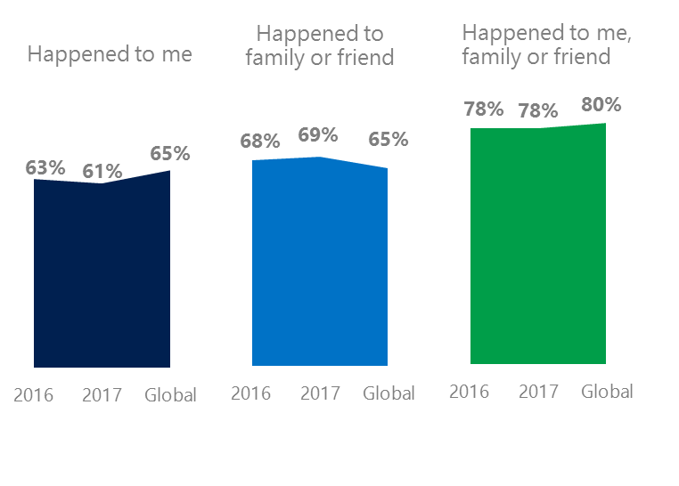Exposure to online risks for individuals, their family or friends were essentially unchanged since 2016.
2. Targets of online risks often named acquaintances, friends or family as perpetrators.
3. Encouraging signs emerged as people began to evolve their approaches towards the challenges of negative online interactions.
4. Millennials (ages 18-34) had the highest lifetime exposure to online risks while Generation X (ages 35-49%) and Baby Boomers (ages 50-74) reported the highest levels of civil behavior.
5. Consequences from bullying and harassment were higher for females than males.

New Intrusive risks had small impact on YOY trend

1India DCI was 61%

India’s ranked seventh out of 23 countries surveyed with a DCI of 61% down two points YOY. Exposure to risks among family or friends held steady and was slightly above the global average (69%, 65%). In 2017, we maintained and added two risks to the Intrusive category and one risk to Behavioral. Without these changes, DCI would have been 59%.

**Intrusive:** Over half of respondents reported an Intrusive risk up three points YOY. Unwanted Contact remained the top risk by a wide margin. Hoaxes, scams and frauds was 10 points lower than the global average.

**Behavioral:** Nearly one-third of Indians experienced a Behavioral risk which was eight points below the global average. Trolling declined YOY and fell below the global average by six points.

**Sexual:** Nearly three in 10 had experienced a Sexual risk including Unwanted Sexting (received or sent, 19%) which was below the global average (25%).

**Reputational:** Reputational risks rose a combined three points YOY led by Damage to Personal and Work reputation.

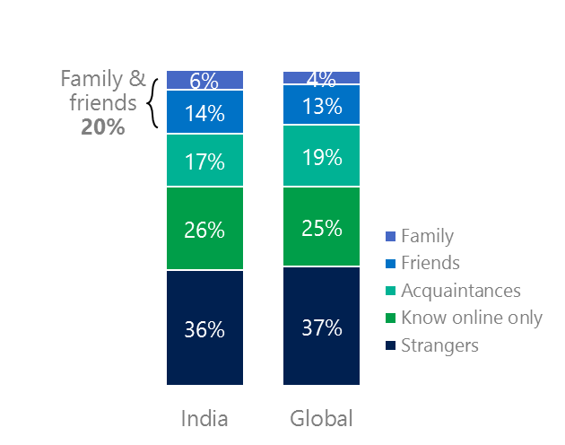2Targets of online risks often named people they knew as perpetrators

20% of perpetrators were family or friends

(among those who said they were treated unsafely or uncivilly)

Although many believe online risks are facilitated by the anonymity provided by the internet, these experiences often involved people they knew personally including family and friends (20%) compared to 17% globally. 77% of respondents said they were treated in a safe and civil manner online, 12 points above the global average (65%).

44% of respondents had met their perpetrator in real life versus 53% globally. Among those who had met their perpetrator, 75% met before the risk occurred. Familiarity with the perpetrator in real life was related to an increased exposure to online risks. The average number of risks was 72% higher among those who had met the perpetrator in real life vs. those who had not (4.7 vs. 2.7).

Familiarity with the perpetrator in real life also affected exposure to consequences. Two-thirds of respondents (67%) suffered at least one consequence from online risks with loss of trust in people online and loss of sleep being the most common. Among those who had met their perpetrator in real life, 40% lost trust in people online and 37% lost sleep. This compared to lost trust in people online (34%) and lost sleep (19%) for those who had not met the perpetrator in real life.

Loss of trust was the biggest consequence

3 Encouraging signs emerged

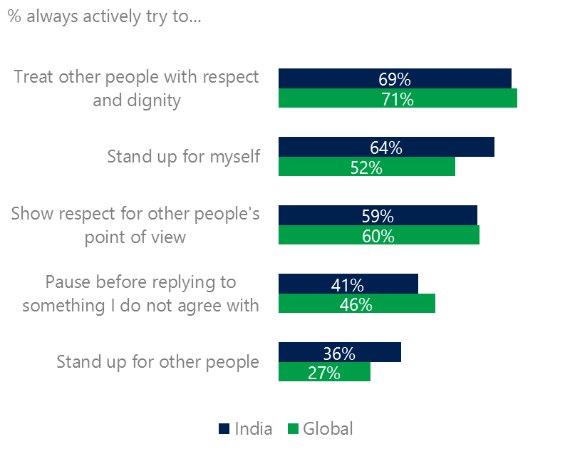Most respondents said they practiced civil behaviors as defined by the Microsoft Digital Civility Challenge, announced in 2017. India exceeded the global averages on standing up for themselves (64%, 52%) and standing up for others (36%, 27%). Respondents were five points lower than the global average for pausing before replying to something they disagreed with.

Reports of civil behavior were widespread

Despite falling 12 points, confidence in managing online was comfortably above the global average (58%, 46%) 44% said they knew where to find help if needed a point lower than the global average.

Females were more likely than males to treat others with respect and dignity (76%, 69%) and respect other people’s point of view (65%, 59%). Generation X (ages 35-49) and Baby Boomers (ages 50-74) reported the highest levels of civil behavior.

4 Millennials had the highest lifetime risk exposure

Nearly eight in 10 Millennials experienced a consequence from online risks

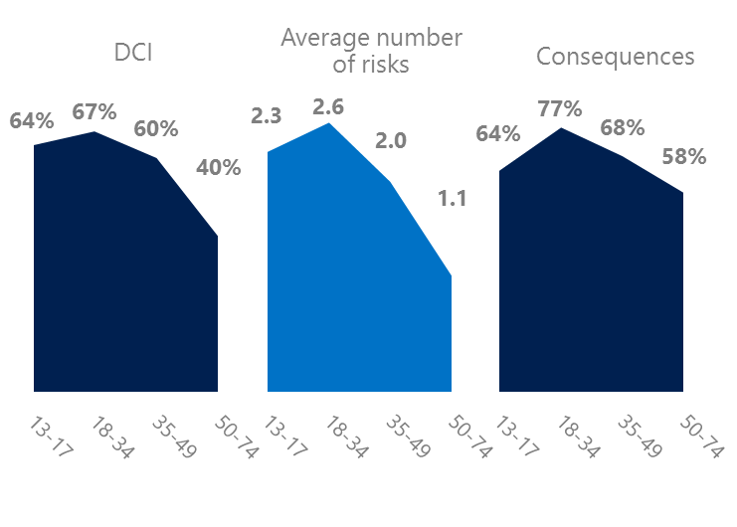Millennial generation respondents (ages 18-34) had the highest levels of risk exposure as measured by DCI (67%) consequences from risks (77%) and average number of risks (2.6). One possible explanation for these high levels is that Millennials were the first generation to grow up in a digital, media-saturated world with abundant free time to explore and experiment. Not surprisingly, Millennials had the highest level of concern about online risks (68%).

Conversely, Baby Boomers (ages 50-74) had the lowest DCI (40%), consequences from risks (58%) and second lowest average number of risks (1.1). More importantly, this age group reported some of the highest levels of civil behavior online as defined by the Microsoft Digital Civility Challenge, announced in 2017. Along with Generation X respondents, they were the most likely to treat others with respect and dignity, stand up for themselves, pause before replying to something they disagreed with and respect other people’s point of view .

Boomers were the most respectful & civil

5 Females bore the brunt of consequences from harassment

Half of respondents reported some form of harassment which ranked ninth out of 23 countries. This study defined harassment as Unwanted Contact, Unwanted Sexting, Online Harassment, Cyberbullying or Misogyny. Males reported higher levels of harassment than females driven by Unwanted Sexting (23%, 16%). However, consequences from harassment were higher for females than males. Females were more likely to lose trust in people online and offline, have greater life stress and had higher rates of depression.

Half of respondents were harassed

Definitions of online risks

1. **Cyberbullying:** When the Internet, phones or other devices are used to send or post text, images, or video intended to hurt, embarrass or intimidate another person.
2. **Damage to Personal reputation:** Damage or destruction to the image created of you through PERSONAL information you or others shared online in blogs, postings, pictures, tweets, videos, etc.
3. **Damage to Professional/Work reputation:** Damage or destruction to the image created of you through work information you or others shared online in blogs, postings, pictures, tweets, videos, etc.
4. **Discrimination:** A person who is discriminated against or excluded based on gender, ethnic origin, religion, race, disability, or sexual orientation.
5. **Doxxing:** The process of collecting and distributing or posting information about a person (e.g., name, age, email, address, phone number, photographs, etc.) without their permission.
6. **Hate speech:** speech that attacks a person or group based on gender, ethnic origin, religion, race, disability, or sexual orientation.
7. **Hoaxes, scams, frauds:** The spreading of false rumors (e.g., chain letters), criminal attempts to obtain personal information often for monetary gain (e.g., phishing scams), malicious emails disguised as someone you know (e.g. virus).
8. **Microaggression:** Casual insults made towards any marginalized group in society (e.g., religious or ethnic minorities, women, LGBT, people with disabilities, etc.).
9. **Misogyny**: An expression or demonstration of dislike, contempt for, or ingrained prejudice against women.
10. **Online harassment:** Threats or other offensive behavior (not sexual solicitation) sent online or posted online for others to see.
11. **Revenge pornography:** A sexually explicit portrayal of one or more people distributed without their consent.
12. **Sextortion:** When someone threatens to distribute your private and sensitive material if you don’t provide them images of a sexual nature, sexual favors, or money. The perpetrator may also threaten to harm your friends or relatives by using information they have obtained from your electronic devices unless you comply with their demands.
13. **Sexual solicitation:** A person who requests to engage in sexual activities or sexual talk or to give personal sexual information that is unwanted.
14. **Swatting:** The act of deceiving emergency services (e.g., police, fire, medical) into sending an emergency response based on the false report of an ongoing critical incident or crime.
15. **Terrorism recruiting:** An attempt by a terrorist or terrorist organization to recruit a person for the purposes of causing harm.
16. **Treated Mean:** Words or messages sent to another person online that are unkind, unfair or malicious.
17. **Trolling:** A deliberate act to make someone mad or angry using online or social media comments in a clever, but deceitful manner.
18. **Unwanted Sexting Sent:** I sent unwanted sexually explicit messages and imagery.
19. **Unwanted Sexting Received:** Received unwanted sexually explicit messages and imagery.
20. **Unwanted contact:** Being personally contacted (by phone or in person) by someone who obtained your information online but without inviting them to contact you.

1. 9 new countries: India, Colombia, Peru, India, Ireland, Italy, Japan, Malaysia, Vietnam

   14 Wave 1 countries: Australia, Belgium, Brazil, Chile, China, France, Germany, India, Mexico, Russia, South Africa, Turkey, UK, U.S.

   3 new online risks: Hoaxes, Frauds and Scams as one collective risk, Microaggression, Misogyny