Microsoft Digital Civility Index (DCI) 2017 – France



The 2017 Civility, Safety and Interaction Online study examines the extent of negative behaviors and online interactions and their consequences. These results build on last year’s study and were based on interviews with teens ages 13-17 and adults ages 18-74. The scope of research increased to encompass 23 countries and 20 online risks (nine newly included countries, three added risks).[1]

Themes for 2017

Risk exposure below the global averages

1. 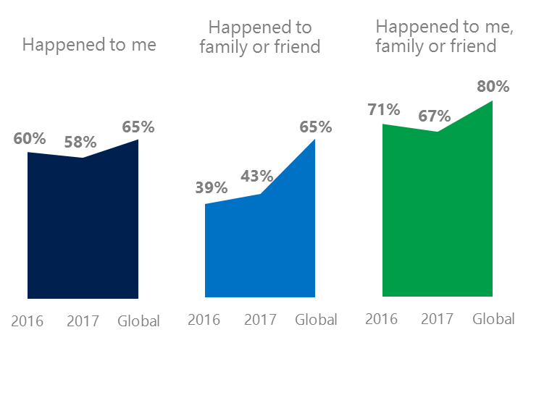French respondents reported exposure to online risks for themselves, family or friends at levels significantly below the global averages.
2. Targets of online risks often named acquaintances, friends or family as perpetrators.
3. Encouraging signs emerged as people began to evolve their approaches towards the challenges of negative online interactions.
4. Boomers (ages 50-74) had the lowest consequences from online risks while teens (ages 13-17) reported the highest.
5. The consequences from bullying and harassment were higher for females and teens than males and adults.



Microaggression drove Behavioral category higher

1France DCI was 58%

France ranked fifth out of 23 countries for exposure to online risks with DCI down two points since 2016. In 2017, we maintained and added two risks to the Intrusive category and one risk to Behavioral. Without these changes, DCI would have been 54%.

**Intrusive:** Unwanted Contact (43%) trended down three points YOY and remained the most prevalent risk. Hoaxes, Scams & Frauds (24%) was ranked second highest among all risks and was slightly below the global average.

**Behavioral:** Behavioral risks rose 11 points YOY driven by the addition of Microaggression which was 50% higher than the global average. The remaining five Behavioral risks were all below the global averages.

**Sexual:** One in four respondents had experienced a Sexual risk down five points from 2016. Unwanted Sexting Received or Sent (17%) was the fourth most common risk overall.

**Reputational:** Reputational risks rose nine points YOY due to a large increase in Doxxing. Both Damage to Personal and Work Reputation also contributed to increases in the category.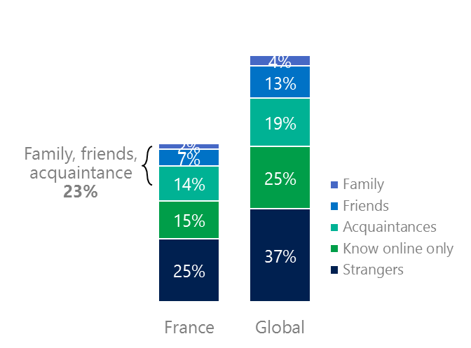2Targets of online risks often named people they knew as perpetrators

23% of perpetrators were family, friends or acquaintances

(among those who said they were treated unsafely or uncivilly)

Although many believe online risks are facilitated by the anonymity provided by the internet, these experiences often involved people they knew personally including family, friends or acquaintances (23%) compared to 36% globally. 43% had met their perpetrator in real life which was up nine points from 2016 but was 10 points less than the global average (53%). Among those who had met their perpetrator, 65% met before the risk occurred, the second lowest percentage behind only Japan (58%). Familiarity with the perpetrator in real life was related to an increased exposure to online risks. The average number of risks was 57% higher among those who had met the perpetrator in real life vs. those who had not (4.1 vs. 2.6).

Familiarity with the perpetrator in real life also affected exposure to consequences. Over six in 10 respondents (65%, +3 points) suffered at least one consequence from online risks with loss of trust online and offline being the most common. Among those who had met their perpetrator in real life, 59% lost trust in people online and 54% lost trust in people offline. This compared to lost trust in people online (35%) and offline (35%) for those who had not met the perpetrator in real life.

Loss of trust was the biggest consequence

3 Encouraging signs emerged

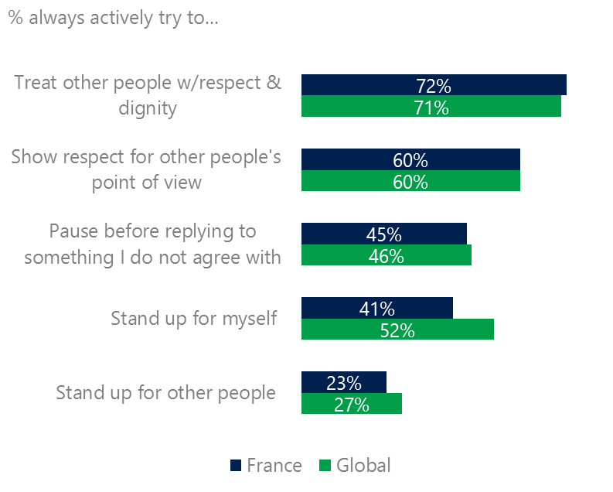France was equal to the global averages (with one exception) for civil behavior as defined by the Microsoft Digital Civility Challenge, announced in 2017. Most respondents stated that they always tried to treat others with respect and dignity and to showed respect for other’s point of view. The only behavior that fell below the global average was standing up for themselves (41%, 52%).

Reports of civil behavior were widespread

31% of respondents said they were extremely or very confident in managing online risks unchanged since 2016 and 15 points below the global average (46%). 31% knew where to find help if needed an increase of 4 points YOY but this was 14 points under the global average (45%).

Females were more likely than males to treat others with respect and dignity (74%, 70%), to show respect for other’s points of view (63%, 56%) and pause before replying to someone they disagreed with (50%, 40%). Respondents ages 50-74 generally reported the highest levels of civil behavior.

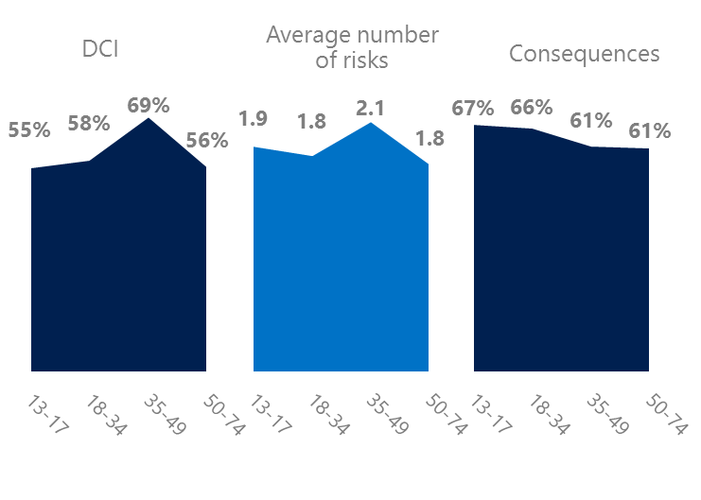4 Boomers had the lowest consequences from online risks

Teens had the highest consequences from online risks

The Baby Boom generation (ages 50-74) had the lowest consequences from risks (61%) and was tied for the lowest DCI (56%) and average number of risks (1.8). As a result, Boomers had the lowest concerns about online risks (25%). More importantly, this age group reported some of the highest levels of civil behavior online as defined by the Microsoft Digital Civility Challenge, announced in 2017. They were more likely to treat others with respect and dignity and to be thoughtful in online exchanges when people disagreed.

Conversely, Generation X respondents (ages 35-49) had the highest levels of risk exposure as measured by DCI (69%) and average number of risks (2.1). Not surprisingly, 35% of Generation X respondents were extremely or very concerned about online risks, the highest among all age groups. Generation X had the highest confidence in managing risks (39% extremely/very confident) which may help explain their relatively low rate of consequences of 61%, eight points lower than the global average. 

Boomers were the most respectful & civil

5 Consequences from harassment were more likely to affect females and teens

France had the seventh lowest rate of harassment (49%) among the 23 countries surveyed. This study defined harassment as Unwanted Contact, Unwanted Sexting, Online Harassment, Cyberbullying or Misogyny. Females more than males reported higher levels of harassment driven by Unwanted Contact (48%, 38%). Adults were more likely to report Unwanted Contact and Unwanted Sexting compared to teens (ages 13-17).

Nearly five in 10 people were harassed

Consequences from most forms of harassment were higher for females and teens than males and adults. Females were 11 points higher than males on lost trust in people offline and 10 points higher on life became more stressful. Teens scored 16 points higher than adults on loss of trust in people offline, nine and points higher on lost trust in people online.

Definitions of online risks

1. **Cyberbullying:** When the Internet, phones or other devices are used to send or post text, images, or video intended to hurt, embarrass or intimidate another person.
2. **Damage to Personal reputation:** Damage or destruction to the image created of you through PERSONAL information you or others shared online in blogs, postings, pictures, tweets, videos, etc.
3. **Damage to Professional/Work reputation:** Damage or destruction to the image created of you through work information you or others shared online in blogs, postings, pictures, tweets, videos, etc.
4. **Discrimination:** A person who is discriminated against or excluded based on gender, ethnic origin, religion, race, disability, or sexual orientation.
5. **Doxxing:** The process of collecting and distributing or posting information about a person (e.g., name, age, email, address, phone number, photographs, etc.) without their permission.
6. **Hate speech:** speech that attacks a person or group based on gender, ethnic origin, religion, race, disability, or sexual orientation.
7. **Hoaxes, scams, frauds:** The spreading of false rumors (e.g., chain letters), criminal attempts to obtain personal information often for monetary gain (e.g., phishing scams), malicious emails disguised as someone you know (e.g. virus).
8. **Microaggression:** Casual insults made towards any marginalized group in society (e.g., religious or ethnic minorities, women, LGBT, people with disabilities, etc.).
9. **Misogyny**: An expression or demonstration of dislike, contempt for, or ingrained prejudice against women.
10. **Online harassment:** Threats or other offensive behavior (not sexual solicitation) sent online or posted online for others to see.
11. **Revenge pornography:** A sexually explicit portrayal of one or more people distributed without their consent.
12. **Sextortion:** When someone threatens to distribute your private and sensitive material if you don’t provide them images of a sexual nature, sexual favors, or money. The perpetrator may also threaten to harm your friends or relatives by using information they have obtained from your electronic devices unless you comply with their demands.
13. **Sexual solicitation:** A person who requests to engage in sexual activities or sexual talk or to give personal sexual information that is unwanted.
14. **Swatting:** The act of deceiving emergency services (e.g., police, fire, medical) into sending an emergency response based on the false report of an ongoing critical incident or crime.
15. **Terrorism recruiting:** An attempt by a terrorist or terrorist organization to recruit a person for the purposes of causing harm.
16. **Treated Mean:** Words or messages sent to another person online that are unkind, unfair or malicious.
17. **Trolling:** A deliberate act to make someone mad or angry using online or social media comments in a clever, but deceitful manner.
18. **Unwanted Sexting Sent:** I sent unwanted sexually explicit messages and imagery.
19. **Unwanted Sexting Received:** Received unwanted sexually explicit messages and imagery.
20. **Unwanted contact:** Being personally contacted (by phone or in person) by someone who obtained your information online but without inviting them to contact you.

1. 9 new countries: Argentina, Colombia, Peru, Hungary, Ireland, Italy, Japan, Malaysia, Vietnam

   14 Wave 1 countries: Australia, Belgium, Brazil, Chile, China, France, Germany, India, Mexico, Russia, South Africa, Turkey, UK, U.S.

   3 new online risks: Hoaxes, Frauds and Scams as one collective risk, Microaggression, Misogyny