Microsoft Digital Civility Index (DCI) 2017 – Colombia



The 2017 Civility, Safety and Interaction Online study examines the extent of negative behaviors and online interactions and their consequences. These results build on last year’s study and were based on interviews with teens ages 13-17 and adults ages 18-74. The scope of research increased to encompass 23 countries and 20 online risks (nine newly included countries, three added risks).[1]

Themes for 2017

Online risk exposure was very high

1. 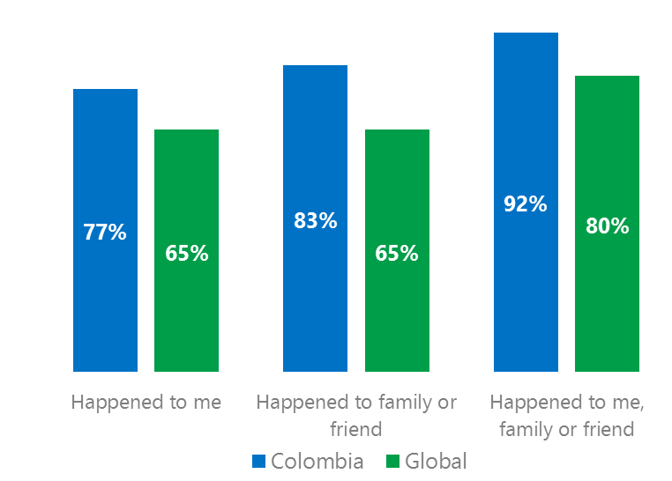Colombians had the third highest level of exposure to online risks among the 23 countries surveyed.
2. Targets of online risks often named acquaintances, friends or family as perpetrators.
3. Efforts towards habitual civil behavior has proved challenging while confidence in managing online risks eroded over the past year.
4. Millennials (ages 18-34) had the highest lifetime exposure to online risks while Baby Boomers (ages 50-74) reported the highest level of civil behavior.
5. Consequences from bullying and harassment were higher for females than males.

More than half suffered from Unwanted Contact

1 Colombia DCI was 77%

Colombia ranked 21st out of 23 countries for exposure to online risks. In 2017, we maintained and added two risks to the Intrusive category and one risk to Behavioral. Without these changes, DCI would have been two points lower to 75%.

**Intrusive:** Over half of respondents reported Unwanted Contact (54%) and together with Hoaxes, scams and frauds drove category 12 points above the global average.

**Sexual:** 48% of Colombians reported a Sexual risk which was 18 points higher than the global average led by Unwanted Sexting Received or Sent (41%) and Sexual Solicitation (26%).

**Behavioral:** The Behavioral category equaled the global average. Trolling and Online Harassment were each five points under the global averages. Microaggression (12%), new in 2017 equaled the global average.

**Reputational:** The top Reputational risk was Doxxing (12%), slightly higher than the global average. Damage to Personal or Work reputation were essentially equal to the global averages.

2Targets of online risks often named 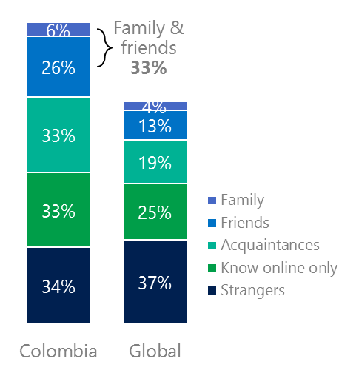people they knew as perpetrators

33% of perpetrators were family or friends

(among those who said they were treated unsafely or uncivilly)

Although many believe online risks are facilitated by the anonymity provided by the internet, these experiences often involved people they knew personally including family and friends (33%) which was nearly twice the global average (17%).

62% had met their perpetrator in real life which was 13 points higher than the global average (53%). Among those who had met their perpetrator, 80% met before the risk occurred. Familiarity with the perpetrator in real life was related to an increased exposure to online risks. The average number of risks was 62% higher among those who had met the perpetrator in real life vs. those who had not (4.6 vs. 2.9 ).

Familiarity with the perpetrator in real life also affected exposure to consequences. Over six in 10 respondents (66%) suffered at least one consequence from online risks with lost trust in people online and offline being the most common. Among those who had met their perpetrator in real life, 48% lost trust in people online and 36% lost trust in people offline. This compared to a lost trust in people online (32%) and offline (19%) for those who had not met the perpetrator in real life.

Loss of trust was the biggest consequence

3 Encouraging signs emerged

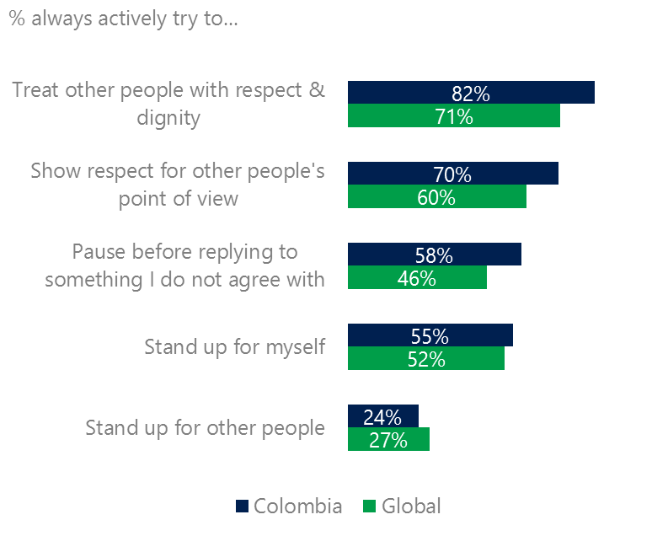Respondents scored above or at the global averages for civil behavior as defined by the Microsoft Digital Civility Challenge, announced in 2017. Colombians were above average on treating others with respect and dignity and being thoughtful in discussions where people disagreed. 30% of respondents said they tried to be more constructive with their criticism of others, five points higher than the global average.

Civil behavior was widespread

One-third (33%) of respondents said they were extremely or very confident in managing online risks down 15 YOY and considerably below the global average (46%). A greater number of respondents did not know where to find help if needed (33%, -10 points YOY) which fell below the global average (45%).

Older respondents tended to be the most likely to treat others with respect and dignity and respect other’s point of view. Teens (ages 13-17) were as likely as older respondents to stand up for themselves and others.

4 Millennials had the highest lifetime risk exposure

73% of Millennials experienced a consequence from an online risk

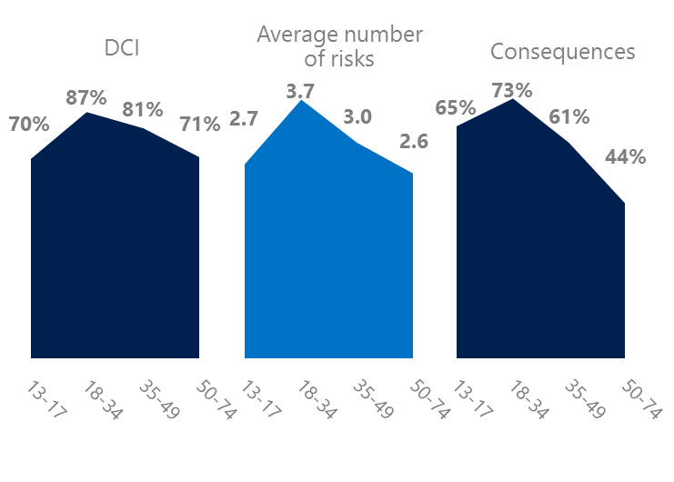Millennial generation respondents (ages 18-34) had the highest levels of risk exposure as measured by DCI (87%), average number of risks (3.7) and consequences from risks (73%). One possible explanation for these high levels is that Millennials were the first generation to grow up in a digital, media-saturated world with abundant free time to explore and experiment. Four in 10 Millennials (40%) were extremely or very concerned about online risks and 22% said they were not treated in a safe or civil manner online.

Conversely, the Baby Boom generation (ages 50-74) had the lowest consequences from risks (44%) and tied for the lowest average number of risks (2.6) and DCI (71%). More importantly, this age group reported some of the highest levels of civil behavior online as defined by the Microsoft Digital Civility Challenge, announced in 2017. They were more likely to treat others with respect and dignity, to be thoughtful in online exchanges when people disagreed and stand up for other people.

Boomers were the most respectful & civil

5 Colombia had the highest rate of harassment

69% of respondents experienced harassment in Colombia which was the highest among the 23 countries surveyed. This was 28% higher than the global average of 54%. This study defined harassment as Unwanted Contact, Unwanted Sexting, Online Harassment, Cyberbullying or Misogyny. Adults reported higher rates of harassment compared to teens (74%, 64%) with the largest gaps being Unwanted Contact (60%, 47%) and Unwanted Sexting (48%, 35%). Overall, females said they encountered harassment more often than males (72%, 66%) and were more likely to suffer the consequence of becoming less trusting of people online (49%, 37%) than males.

Nearly seven in 10 people were harassed

Definitions of online risks

1. **Cyberbullying:** When the Internet, phones or other devices are used to send or post text, images, or video intended to hurt, embarrass or intimidate another person.
2. **Damage to Personal reputation:** Damage or destruction to the image created of you through PERSONAL information you or others shared online in blogs, postings, pictures, tweets, videos, etc.
3. **Damage to Professional/Work reputation:** Damage or destruction to the image created of you through work information you or others shared online in blogs, postings, pictures, tweets, videos, etc.
4. **Discrimination:** A person who is discriminated against or excluded based on gender, ethnic origin, religion, race, disability, or sexual orientation.
5. **Doxxing:** The process of collecting and distributing or posting information about a person (e.g., name, age, email, address, phone number, photographs, etc.) without their permission.
6. **Hate speech:** speech that attacks a person or group based on gender, ethnic origin, religion, race, disability, or sexual orientation.
7. **Hoaxes, scams, frauds:** The spreading of false rumors (e.g., chain letters), criminal attempts to obtain personal information often for monetary gain (e.g., phishing scams), malicious emails disguised as someone you know (e.g. virus).
8. **Microaggression:** Casual insults made towards any marginalized group in society (e.g., religious or ethnic minorities, women, LGBT, people with disabilities, etc.).
9. **Misogyny**: An expression or demonstration of dislike, contempt for, or ingrained prejudice against women.
10. **Online harassment:** Threats or other offensive behavior (not sexual solicitation) sent online or posted online for others to see.
11. **Revenge pornography:** A sexually explicit portrayal of one or more people distributed without their consent.
12. **Sextortion:** When someone threatens to distribute your private and sensitive material if you don’t provide them images of a sexual nature, sexual favors, or money. The perpetrator may also threaten to harm your friends or relatives by using information they have obtained from your electronic devices unless you comply with their demands.
13. **Sexual solicitation:** A person who requests to engage in sexual activities or sexual talk or to give personal sexual information that is unwanted.
14. **Swatting:** The act of deceiving emergency services (e.g., police, fire, medical) into sending an emergency response based on the false report of an ongoing critical incident or crime.
15. **Terrorism recruiting:** An attempt by a terrorist or terrorist organization to recruit a person for the purposes of causing harm.
16. **Treated Mean:** Words or messages sent to another person online that are unkind, unfair or malicious.
17. **Trolling:** A deliberate act to make someone mad or angry using online or social media comments in a clever, but deceitful manner.
18. **Unwanted Sexting Sent:** I sent unwanted sexually explicit messages and imagery.
19. **Unwanted Sexting Received:** Received unwanted sexually explicit messages and imagery.
20. **Unwanted contact:** Being personally contacted (by phone or in person) by someone who obtained your information online but without inviting them to contact you.

1. 9 new countries: Argentina, Colombia, Peru, Hungary, Ireland, Italy, Japan, Malaysia, Vietnam

   14 Wave 1 countries: Australia, Belgium, Brazil, Chile, China, France, Germany, India, Mexico, Russia, South Africa, Turkey, UK, U.S.

   3 new online risks: Hoaxes, Frauds and Scams as one collective risk, Microaggression, Misogyny