Microsoft Digital Civility Index (DCI) 2017 – China



The 2017 Civility, Safety and Interaction Online study examines the extent of negative behaviors and online interactions and their consequences. These results build on last year’s study and were based on interviews with teens ages 13-17 and adults ages 18-74. The scope of research increased to encompass 23 countries and 20 online risks (nine newly included countries, three added risks).[1]

Themes for 2017

China’s risk exposure fell since 2016

1. 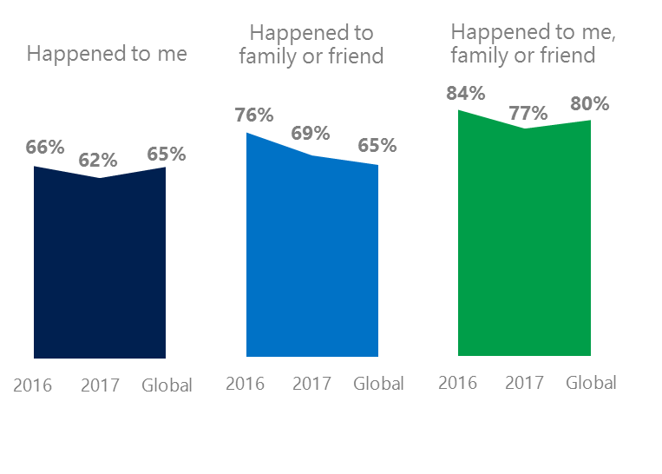The level of online risks held steady for respondents and their family and friends since 2016. Chileans experienced risks at rates above the global averages.
2. Targets of online risks often named acquaintances, friends or family as perpetrators.
3. Efforts towards habitual civil behavior has proved challenging while confidence in managing online risks eroded over the past year.
4. Millennials (ages 18-34) had the highest lifetime exposure to online risks while Baby Boomers (ages 50-74) reported the highest level of civil behavior.
5. Adults reported higher rates of harassment than teens.

Big drop in Doxxing lowered Reputational category

1 China DCI was 62%

China ranked ninth out of 23 countries for exposure to online risks with DCI down four points since 2016. In 2017, we maintained and added two risks to the Intrusive category and one risk to Behavioral. Without these changes, DCI would have been nine points lower to 57 %.

**Intrusive:** The addition of Hoaxes, Scams & Frauds (29%) and Misogyny (6%) lifted the category up five points YOY. Unwanted Contact (29%) remained the top risk overall, but fell six points YOY.

**Behavioral:** Behavioral risks were down 3 points YOY and equal to the global average. Online Harassment registered the largest drop of five points YOY. Microaggression (9%), new in 2017 came in three points below the global average.

**Sexual:** About one in three respondents experienced a Sexual risk down two points since 2016. Unwanted Sexting Received or Sent (30%) remained the top risk overall down two points YOY.

**Reputational:** An unprecedented decline in Doxxing (-30 points) drove the Reputational category down 25 points YOY. Damage to Personal Reputation (10%, +2 points) was the most common risk.

2Targets of online risks often named 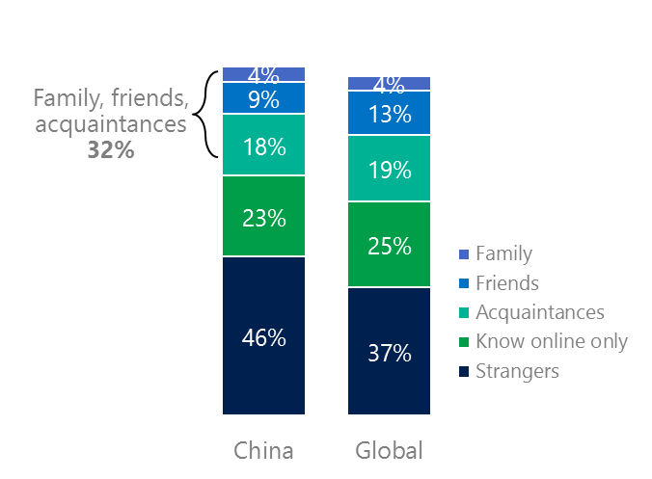people they knew as perpetrators

32% of perpetrators were family, friends or acquaintances

(among those who said they were treated unsafely or uncivilly)

Although many believe online risks are facilitated by the anonymity provided by the internet, these experiences often involved people they knew personally including family and friends and acquaintances (32%) compared to 36% globally. Nearly half (46%) said the perpetrator was a stranger which was above the global average.

69% had met their perpetrator in real life down 11 points from 2016 and 16 points higher than the global average (53%). Among those who had met their perpetrator, 75% met before the risk occurred. Familiarity with the perpetrator in real life was related to an increased exposure to online risks. The average number of risks was 75% higher among those who had met the perpetrator in real life vs. those who had not (4.5 vs. 2.6).

Familiarity with the perpetrator in real life also affected exposure to consequences. Seven in 10 respondents (70%, +4 points YOY) suffered at least one consequence from online risks with lost trust in people online and offline and lost sleep being the three most common. Among those who had met their perpetrator in real life, 50% lost trust in people online and 38% lost trust in people offline. This compared to lost trust in people online (40%) and offline (19%) for those who had not met the perpetrator in real life.

Loss of trust was the biggest consequence

3 Confidence in managing risks fell

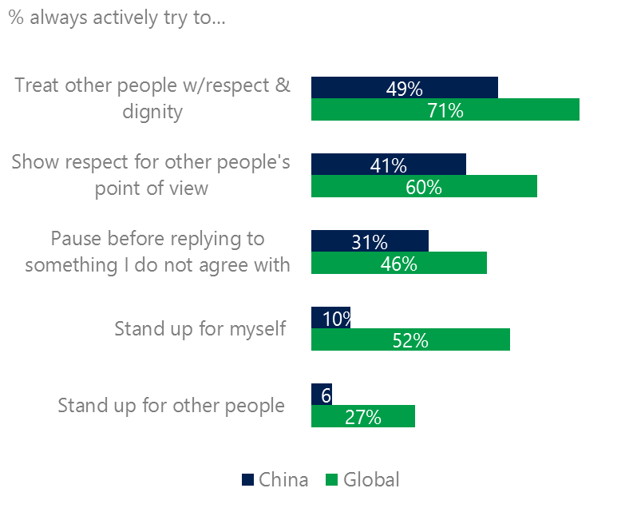China scored significantly below the global averages for civil behavior as defined by the Microsoft Digital Civility Challenge, announced in 2017. Respondents reported below average scores on all measures with the largest gaps being standing up for myself (42 points below avg.) and actively trying to treat others with respect and dignity (22 points below avg.).

Civil behavior online is a work in progress

One-third (33%) of respondents said they were extremely or very confident in managing online risks down 15 points YOY and considerably below the global average (46%). A greater number of respondents did not know where to find help if needed (33%, -10 points YOY) which fell below the global average (45%).

Teens were more likely than adults to always or sometimes stand up for themselves (42%, 31%). Boomers (ages 50-74) were the most likely to treat others with respect and dignity and respect other people’s point of view.

4 Millennials had the highest lifetime risk exposure

Millennials had the highest average number of online risks

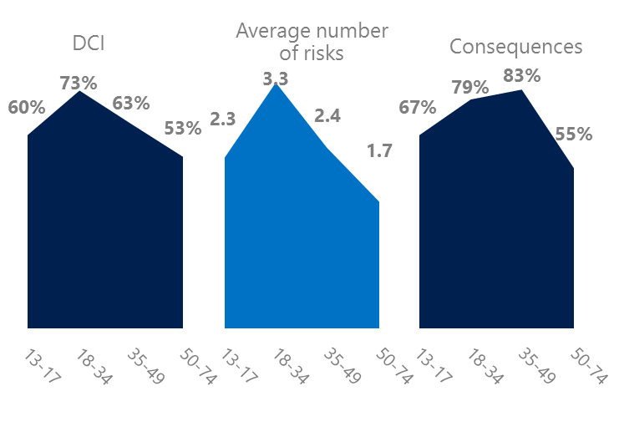Millennial generation respondents (ages 18-34) had the highest levels of risk exposure as measured by DCI (73%), average number of risks (3.3) and the second highest level of consequences. One possible explanation for these high levels is that Millennials were the first generation to grow up in a digital, media-saturated world with abundant free time to explore and experiment. Slightly over four in 10 Millennials (42%) were extremely or very concerned about online risks – highest among all age groups. Millennials were most worried about Doxxing (35%) and Damage to Personal Reputation (21%).

Conversely, the Baby Boom generation (ages 50-74) had the lowest DCI (53%), average number of risks (1.7) and consequences from risks (55%). More importantly, this age group reported some of the highest levels of civil behavior online as defined by the Microsoft Digital Civility Challenge, announced in 2017. They were more likely to treat others with respect and dignity and to be thoughtful in online exchanges when people disagreed. Younger generations were more likely than Boomers to stand up for themselves and for others.

Boomers were the most respectful & civil

5 Harassment was higher for adults than teens

Half of respondents experienced harassment in China which ranked eighth out of 23 countries surveyed. This study defined harassment as Unwanted Contact, Unwanted Sexting, Online Harassment, Cyberbullying or Misogyny. Adults reported higher rates of harassment overall compared to teens (54%, 46%) with the largest gap being Unwanted Sexting (35%, 25%). The level of consequences from online risks were similar for both genders. The same was true for adults and teens.

Half of respondents were harassed

Definitions of online risks

1. **Cyberbullying:** When the Internet, phones or other devices are used to send or post text, images, or video intended to hurt, embarrass or intimidate another person.
2. **Damage to Personal reputation:** Damage or destruction to the image created of you through PERSONAL information you or others shared online in blogs, postings, pictures, tweets, videos, etc.
3. **Damage to Professional/Work reputation:** Damage or destruction to the image created of you through work information you or others shared online in blogs, postings, pictures, tweets, videos, etc.
4. **Discrimination:** A person who is discriminated against or excluded based on gender, ethnic origin, religion, race, disability, or sexual orientation.
5. **Doxxing:** The process of collecting and distributing or posting information about a person (e.g., name, age, email, address, phone number, photographs, etc.) without their permission.
6. **Hate speech:** speech that attacks a person or group based on gender, ethnic origin, religion, race, disability, or sexual orientation.
7. **Hoaxes, scams, frauds:** The spreading of false rumors (e.g., chain letters), criminal attempts to obtain personal information often for monetary gain (e.g., phishing scams), malicious emails disguised as someone you know (e.g. virus).
8. **Microaggression:** Casual insults made towards any marginalized group in society (e.g., religious or ethnic minorities, women, LGBT, people with disabilities, etc.).
9. **Misogyny**: An expression or demonstration of dislike, contempt for, or ingrained prejudice against women.
10. **Online harassment:** Threats or other offensive behavior (not sexual solicitation) sent online or posted online for others to see.
11. **Revenge pornography:** A sexually explicit portrayal of one or more people distributed without their consent.
12. **Sextortion:** When someone threatens to distribute your private and sensitive material if you don’t provide them images of a sexual nature, sexual favors, or money. The perpetrator may also threaten to harm your friends or relatives by using information they have obtained from your electronic devices unless you comply with their demands.
13. **Sexual solicitation:** A person who requests to engage in sexual activities or sexual talk or to give personal sexual information that is unwanted.
14. **Swatting:** The act of deceiving emergency services (e.g., police, fire, medical) into sending an emergency response based on the false report of an ongoing critical incident or crime.
15. **Terrorism recruiting:** An attempt by a terrorist or terrorist organization to recruit a person for the purposes of causing harm.
16. **Treated Mean:** Words or messages sent to another person online that are unkind, unfair or malicious.
17. **Trolling:** A deliberate act to make someone mad or angry using online or social media comments in a clever, but deceitful manner.
18. **Unwanted Sexting Sent:** I sent unwanted sexually explicit messages and imagery.
19. **Unwanted Sexting Received:** Received unwanted sexually explicit messages and imagery.
20. **Unwanted contact:** Being personally contacted (by phone or in person) by someone who obtained your information online but without inviting them to contact you.

1. 9 new countries: Argentina, Colombia, Peru, Hungary, Ireland, Italy, Japan, Malaysia, Vietnam

   14 Wave 1 countries: Australia, Belgium, Brazil, Chile, China, France, Germany, India, Mexico, Russia, South Africa, Turkey, UK, U.S.

   3 new online risks: Hoaxes, Frauds and Scams as one collective risk, Microaggression, Misogyny