Microsoft Digital Civility Index (DCI) 2017 – Chile



The 2017 Civility, Safety and Interaction Online study examines the extent of negative behaviors and online interactions and their consequences. These results build on last year’s study and were based on interviews with teens ages 13-17 and adults ages 18-74. The scope of research increased to encompass 23 countries and 20 online risks (nine newly included countries, three added risks).[1]

Themes for 2017

DCI held steady

1. 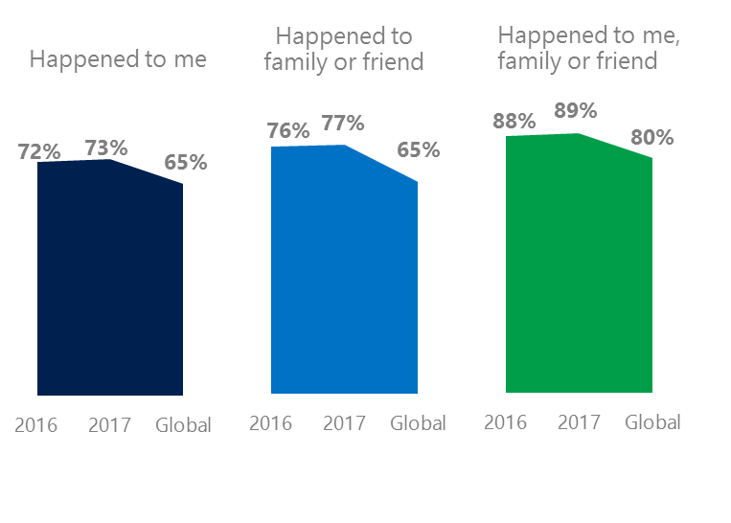The level of online risks held steady for respondents and their family and friends since 2016. Chileans experienced risks at rates above the global averages.
2. Targets of online risks often named acquaintances, friends or family as perpetrators.
3. Encouraging signs emerged as people began to evolve their approaches towards the challenges of negative online interactions.
4. Millennials (ages 18-34) had the highest lifetime exposure to online risks while Baby Boomers (ages 50-74) reported the highest level of civil behavior.
5. Consequences from bullying and harassment were higher for females than males.

New risks pushed Intrusive category higher YOY

1 Chile DCI was 73%

Chile ranked 17th out of 23 countries for exposure to online risks with DCI up one point since 2016. In 2017, we maintained and added two risks to the Intrusive category and one risk to Behavioral. Without these changes, DCI would have fallen two points to 70%.

**Intrusive:** The addition of Hoaxes, Scams & Frauds (32%) and Misogyny (6%) lifted the category up five points YOY. Unwanted Contact (53%) remained the top risk overall, and was 12 points higher than the global average.

**Sexual:** Nearly four in 10 respondents experienced a Sexual risk unchanged since 2016. Unwanted Sexting Received or Sent (31%) remained the top risk down a point YOY.

**Behavioral:** Behavioral risks were flat YOY and slightly under the global average. Trolling dropped eight points but did not drive the category down due to a large overlap with being Treated Mean. Microaggression (14%), new in 2017 came in two points above the global average.

**Reputational:** Reputational risks held steady YOY, and stayed close to the global average. Damage to Personal Reputation (10%, -3 points) was the most common risk.

2Targets of online risks often named 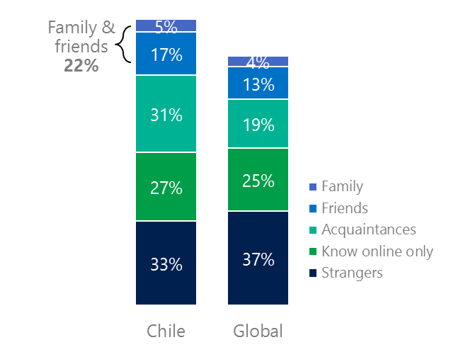people they knew as perpetrators

22% of perpetrators were family or friends

(among those who said they were treated unsafely or uncivilly)

Although many believe online risks are facilitated by the anonymity provided by the internet, these experiences often involved people they knew personally including family and friends (22%) compared to 17% globally. 58% had met their perpetrator in real life up eight points from 2016 and five points higher than the global average (53%). Among those who had met their perpetrator, 72% met before the risk occurred. Familiarity with the perpetrator in real life was related to an increased exposure to online risks. The average number of risks was 79% higher among those who had met the perpetrator in real life vs. those who had not (4.7 vs. 2.6).

Familiarity with the perpetrator in real life also affected exposure to consequences. Over six in 10 respondents (63%, -6 points) suffered at least one consequence from online risks with loss of trust online and offline being the most common. Among those who had met their perpetrator in real life, 55% lost trust in people online and 42% lost trust in people offline. This compared to lost trust in people online (30%) and offline (17%) for those who had not met the perpetrator in real life.

Loss of trust was the biggest consequence

3 Encouraging signs emerged

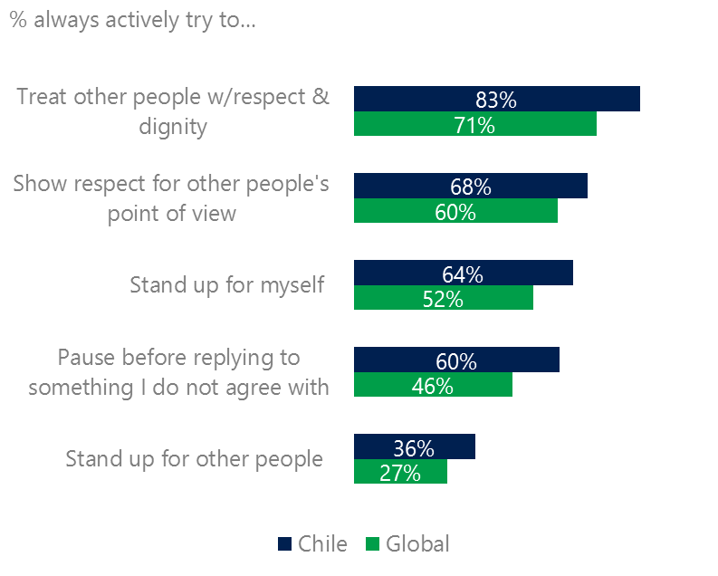Chileans scored above the global averages for civil behavior as defined by the Microsoft Digital Civility Challenge, announced in 2017. They exceeded the averages on all measures with the largest gaps being actively trying to treat others with respect and dignity (83%, 71%) and pausing before replying to something I disagree with (60%, 46%).

Reports of civil behavior were widespread

Over half (53%) of respondents said they were extremely or very confident in managing online risks up nine points YOY and rose above the global average (46%). A greater number of respondents knew where to find help if needed (56%, +11 points YOY) which exceeded the global average (45%).

Females were more likely to stand up for themselves (85%, 78%) and stand up for others (70%, 65%) than males. Like females, Generation X (ages 35-49) respondents were the most likely to stand up for themselves and others.

4 Millennials had the highest exposure to risks and their consequences

76% of Millennials experienced a consequence from an online risk

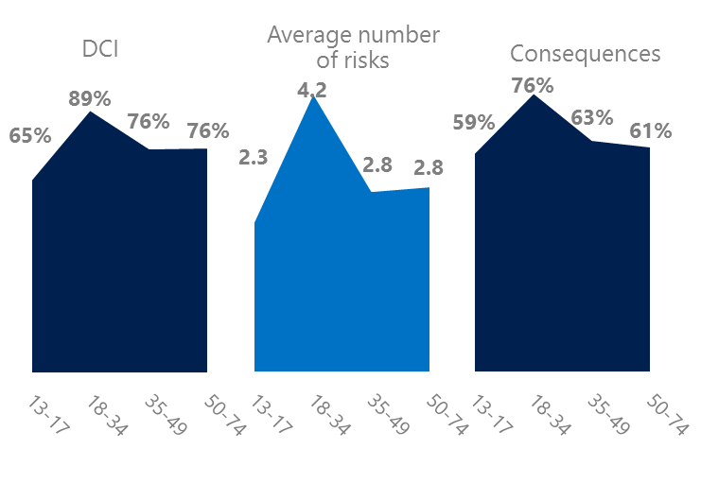Millennial generation respondents (ages 18-34) had the highest levels of risk exposure as measured by DCI (89%), consequences from risks (76%), the average number of risks (4.2). One possible explanation for these high levels is that Millennials were the first generation to grow up in a digital, media-saturated world with abundant free time to explore and experiment. Slightly over half of Millennials (37%) were extremely or very concerned about online risks and 23% said they were not treated in a safe or civil manner online.

Conversely, the Baby Boom generation (ages 50-74) were tied for the lowest average number of risks (2.8) and consequences from risks (61%). More importantly, this age group reported some of the highest levels of civil behavior online as defined by the Microsoft Digital Civility Challenge, announced in 2017. Respondents from Generation X (ages 35-49) scored highest on standing up for themselves and for others while Millennials along with Baby Boomers were most likely to pause before replying to something they disagreed with.

Boomers were the most respectful & civil

5 Consequences from harassment were higher for adults and females

Brazil had the fifth highest rate of harassment (64%) among the 23 countries surveyed. This study defined harassment as Unwanted Contact, Unwanted Sexting, Online Harassment, Cyberbullying or Misogyny. Females reported higher rates of harassment versus males (68%, 60%) driven by Unwanted Contact and Online Harassment. Adults said they encountered more harassment than teens (71%, 57%).

Over six in 10 people were harassed

The severity of consequences from harassment were higher for adults than teens and to a lesser extent female more than male. Females were 11 points higher than males on lost trust in people offline and eight points higher on became depressed. Consequences for adults were higher than teens on lost trust in people online (37%, 28%), lost trust in people offline (49%, 42%) and life became more stressful (28%, 20%).

Definitions of online risks

1. **Cyberbullying:** When the Internet, phones or other devices are used to send or post text, images, or video intended to hurt, embarrass or intimidate another person.
2. **Damage to Personal reputation:** Damage or destruction to the image created of you through PERSONAL information you or others shared online in blogs, postings, pictures, tweets, videos, etc.
3. **Damage to Professional/Work reputation:** Damage or destruction to the image created of you through work information you or others shared online in blogs, postings, pictures, tweets, videos, etc.
4. **Discrimination:** A person who is discriminated against or excluded based on gender, ethnic origin, religion, race, disability, or sexual orientation.
5. **Doxxing:** The process of collecting and distributing or posting information about a person (e.g., name, age, email, address, phone number, photographs, etc.) without their permission.
6. **Hate speech:** speech that attacks a person or group based on gender, ethnic origin, religion, race, disability, or sexual orientation.
7. **Hoaxes, scams, frauds:** The spreading of false rumors (e.g., chain letters), criminal attempts to obtain personal information often for monetary gain (e.g., phishing scams), malicious emails disguised as someone you know (e.g. virus).
8. **Microaggression:** Casual insults made towards any marginalized group in society (e.g., religious or ethnic minorities, women, LGBT, people with disabilities, etc.).
9. **Misogyny**: An expression or demonstration of dislike, contempt for, or ingrained prejudice against women.
10. **Online harassment:** Threats or other offensive behavior (not sexual solicitation) sent online or posted online for others to see.
11. **Revenge pornography:** A sexually explicit portrayal of one or more people distributed without their consent.
12. **Sextortion:** When someone threatens to distribute your private and sensitive material if you don’t provide them images of a sexual nature, sexual favors, or money. The perpetrator may also threaten to harm your friends or relatives by using information they have obtained from your electronic devices unless you comply with their demands.
13. **Sexual solicitation:** A person who requests to engage in sexual activities or sexual talk or to give personal sexual information that is unwanted.
14. **Swatting:** The act of deceiving emergency services (e.g., police, fire, medical) into sending an emergency response based on the false report of an ongoing critical incident or crime.
15. **Terrorism recruiting:** An attempt by a terrorist or terrorist organization to recruit a person for the purposes of causing harm.
16. **Treated Mean:** Words or messages sent to another person online that are unkind, unfair or malicious.
17. **Trolling:** A deliberate act to make someone mad or angry using online or social media comments in a clever, but deceitful manner.
18. **Unwanted Sexting Sent:** I sent unwanted sexually explicit messages and imagery.
19. **Unwanted Sexting Received:** Received unwanted sexually explicit messages and imagery.
20. **Unwanted contact:** Being personally contacted (by phone or in person) by someone who obtained your information online but without inviting them to contact you.

1. 9 new countries: Argentina, Colombia, Peru, Hungary, Ireland, Italy, Japan, Malaysia, Vietnam

   14 Wave 1 countries: Australia, Belgium, Brazil, Chile, China, France, Germany, India, Mexico, Russia, South Africa, Turkey, UK, U.S.

   3 new online risks: Hoaxes, Frauds and Scams as one collective risk, Microaggression, Misogyny