Microsoft Digital Civility Index (DCI) 2017 – Brazil



The 2017 Civility, Safety and Interaction Online study examines the extent of negative behaviors and online interactions and their consequences. These results build on last year’s study and were based on interviews with teens ages 13-17 and adults ages 18-74. The scope of research increased to encompass 23 countries and 20 online risks (nine newly included countries, three added risks).[1]

Themes for 2017

DCI unchanged since last year

1. 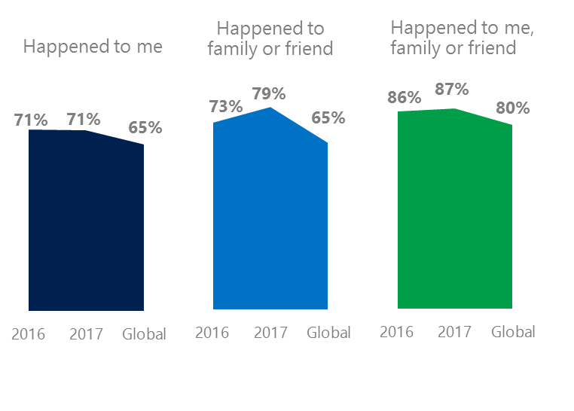The level of online risks was unchanged since 2016 but increased among family and friends. Brazilians experienced risks at rates above the global averages.
2. Targets of online risks often named acquaintances, friends or family as perpetrators.
3. Encouraging signs emerged as people began to evolve their approaches towards the challenges of negative online interactions.
4. Millennials (ages 18-34) had the highest lifetime exposure to online risks while Baby Boomers (ages 50-74) reported the highest level of civil behavior.
5. Consequences from bullying and harassment were higher for females than males.

Behavioral risks fell led by a drop in Trolling

1 Brazil DCI was 71%

Brazil ranked 13th out of 23 countries for exposure to online risks with DCI unchanged since 2016. In 2017, we maintained and added two risks to the Intrusive category and one risk to Behavioral. Without these changes, DCI would have been 69%.

**Intrusive:** The addition of Hoaxes, Scams & Frauds (21%) and Misogyny (5%) lifted the category up four points YOY. Unwanted Contact (51%) remained the top risk overall, and was 10 points higher than the global average.

**Behavioral:** Behavioral risks fell five points YOY led by a decline in Trolling (-6). This offset an increase in Cyberbullying (+4). Microaggression (10%), new in 2017 came in two points below the global average.

**Sexual:** Nearly four in 10 respondents experienced a Sexual risk like 2016. Unwanted Sexting Received or Sent (25%) remained the top risk down two points YOY.

**Reputational:** Reputational risks held steady YOY, but were four points above global average. Doxxing decreased four points YOY but the decline was largely offset by an increase in Damage to Personal Reputation (10%, +3 points).

2Targets of online risks often named 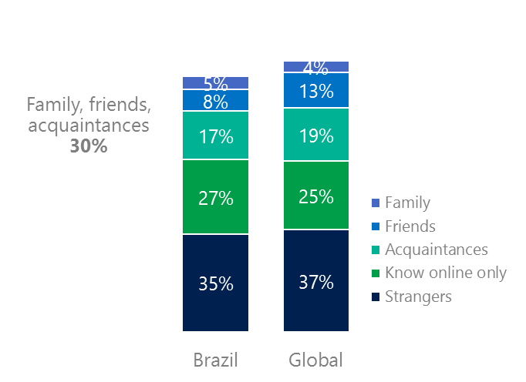people they knew as perpetrators

30% of perpetrators were family, friends or acquaintances

(among those who said they were treated unsafely or uncivilly)

Although many believe online risks are facilitated by the anonymity provided by the internet, these experiences often involved people they knew personally including family, friends or acquaintances (30%) compared to 36% globally. 57% had met their perpetrator in real life down 11 points from 2016 and three points higher than the global average (53%). Among those who had met their perpetrator, 68% met before the risk occurred. Familiarity with the perpetrator in real life was related to an increased exposure to online risks. The average number of risks was 66% higher among those who had met the perpetrator in real life vs. those who had not (4.6 vs. 2.8).

Familiarity with the perpetrator in real life also affected exposure to consequences. Over seven in 10 respondents (72%, +5 points YOY) suffered at least one consequence from online risks with loss of trust online and offline being the most common. Among those who had met their perpetrator in real life, 60% lost trust in people online and 46% lost trust in people offline. This compared to lost trust in people online (46%) and offline (34%) for those who had not met the perpetrator in real life.

Loss of trust was the biggest consequence

3 Encouraging signs emerged

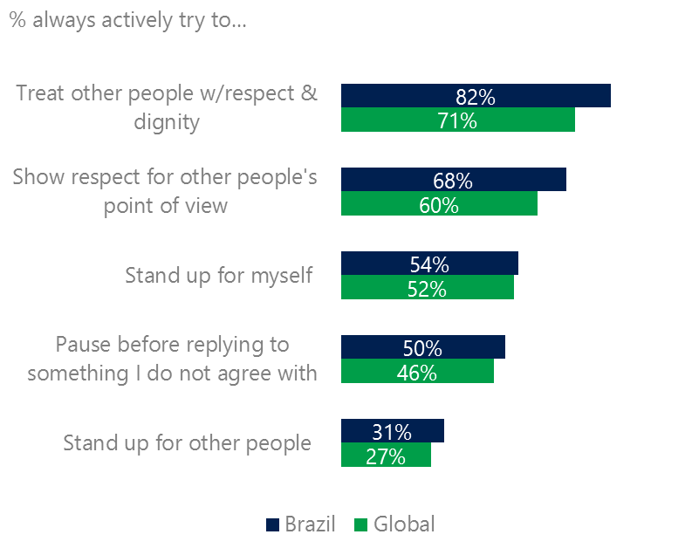Brazilians scored above or at the global averages for civil behavior as defined by the Microsoft Digital Civility Challenge, announced in 2017. They exceeded the averages on actively trying to treat others with respect and dignity (82%, 71%) and showing respect for other’s point of view (68, 60%).

Reports of civil behavior were widespread

Over half (55%) of respondents said they were extremely or very confident in managing online risks although this was down 16 points YOY and remained above the global average (46%). A greater number of respondents knew where to find help if needed (46%, +4 points YOY) which nearly matched the global average (45%).

Females reported higher levels of civil behavior than males. Females scored higher than males on pausing before replying to something they disagreed with (88%, 74%) and standing up for others (74%, 63%). Respondents ages 50-74 reported the highest levels of civil behavior.

4 Millennials had the highest incidence of consequences from online risks

Eight in 10 Millennials experienced a consequence from online risks

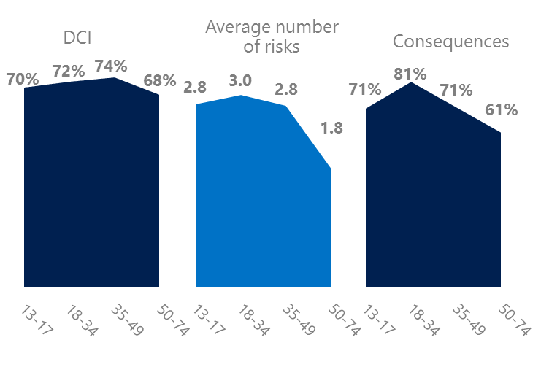Millennial generation respondents (ages 18-34) had the highest levels of risk exposure as measured by consequences from risks (81%), the average number of risks (3.0) and second highest DCI. One possible explanation for these high levels is that Millennials were the first generation to grow up in a digital, media-saturated world with abundant free time to explore and experiment. Slightly over half of Millennials (51%) were extremely or very concerned about online risks and 23% said they were not treated in a safe or civil manner online.

Conversely, the Baby Boom generation (ages 50-74) had the lowest DCI, average number of risks (1.8) and consequences from risks (61%). More importantly, this age group reported some of the highest levels of civil behavior online as defined by the Microsoft Digital Civility Challenge, announced in 2017. They were more likely to treat others with respect and dignity and to be thoughtful in online exchanges when people disagreed. Teens were more likely than Boomers to stand up for other people and equally likely to stand up for themselves.

Boomers were the most respectful & civil

5 Consequences from harassment were higher for females and teens

Brazil had the seventh highest rate of harassment (62%) among the 23 countries surveyed. This study defined harassment as Unwanted Contact, Unwanted Sexting, Online Harassment, Cyberbullying or Misogyny. Females reported higher rates of harassment versus males (65%, 58%) driven by Unwanted Contact and Online Harassment. Adults said they encountered more harassment than teens (66%, 58%).

Over six in 10 people were harassed

The severity of consequences from all forms of harassment were higher for females than males and to some lesser extent teens more than adults. Females were 10 points higher than males on lost trust in people offline and seven points higher on lost trust in people online. Similarly, consequences for teens were higher than adults on became depressed (39%, 19%), lost trust in people online (48%, 38%) and lost trust in people offline (59%, 53%).

Definitions of online risks

1. **Cyberbullying:** When the Internet, phones or other devices are used to send or post text, images, or video intended to hurt, embarrass or intimidate another person.
2. **Damage to Personal reputation:** Damage or destruction to the image created of you through PERSONAL information you or others shared online in blogs, postings, pictures, tweets, videos, etc.
3. **Damage to Professional/Work reputation:** Damage or destruction to the image created of you through work information you or others shared online in blogs, postings, pictures, tweets, videos, etc.
4. **Discrimination:** A person who is discriminated against or excluded based on gender, ethnic origin, religion, race, disability, or sexual orientation.
5. **Doxxing:** The process of collecting and distributing or posting information about a person (e.g., name, age, email, address, phone number, photographs, etc.) without their permission.
6. **Hate speech:** speech that attacks a person or group based on gender, ethnic origin, religion, race, disability, or sexual orientation.
7. **Hoaxes, scams, frauds:** The spreading of false rumors (e.g., chain letters), criminal attempts to obtain personal information often for monetary gain (e.g., phishing scams), malicious emails disguised as someone you know (e.g. virus).
8. **Microaggression:** Casual insults made towards any marginalized group in society (e.g., religious or ethnic minorities, women, LGBT, people with disabilities, etc.).
9. **Misogyny**: An expression or demonstration of dislike, contempt for, or ingrained prejudice against women.
10. **Online harassment:** Threats or other offensive behavior (not sexual solicitation) sent online or posted online for others to see.
11. **Revenge pornography:** A sexually explicit portrayal of one or more people distributed without their consent.
12. **Sextortion:** When someone threatens to distribute your private and sensitive material if you don’t provide them images of a sexual nature, sexual favors, or money. The perpetrator may also threaten to harm your friends or relatives by using information they have obtained from your electronic devices unless you comply with their demands.
13. **Sexual solicitation:** A person who requests to engage in sexual activities or sexual talk or to give personal sexual information that is unwanted.
14. **Swatting:** The act of deceiving emergency services (e.g., police, fire, medical) into sending an emergency response based on the false report of an ongoing critical incident or crime.
15. **Terrorism recruiting:** An attempt by a terrorist or terrorist organization to recruit a person for the purposes of causing harm.
16. **Treated Mean:** Words or messages sent to another person online that are unkind, unfair or malicious.
17. **Trolling:** A deliberate act to make someone mad or angry using online or social media comments in a clever, but deceitful manner.
18. **Unwanted Sexting Sent:** I sent unwanted sexually explicit messages and imagery.
19. **Unwanted Sexting Received:** Received unwanted sexually explicit messages and imagery.
20. **Unwanted contact:** Being personally contacted (by phone or in person) by someone who obtained your information online but without inviting them to contact you.

1. 9 new countries: Argentina, Colombia, Peru, Hungary, Ireland, Italy, Japan, Malaysia, Vietnam

   14 Wave 1 countries: Australia, Belgium, Brazil, Chile, China, France, Germany, India, Mexico, Russia, South Africa, Turkey, UK, U.S.

   3 new online risks: Hoaxes, Frauds and Scams as one collective risk, Microaggression, Misogyny