Microsoft Digital Civility Index (DCI) 2017 – Australia



The 2017 Civility, Safety and Interaction Online study examines the extent of negative behaviors and online interactions and their consequences. These results build on last year’s study and were based on interviews with teens ages 13-17 and adults ages 18-74. The scope of research increased to encompass 23 countries and 20 online risks (nine newly included countries, three added risks).[1]

Themes for 2017

Risk exposure below the global averages

1. 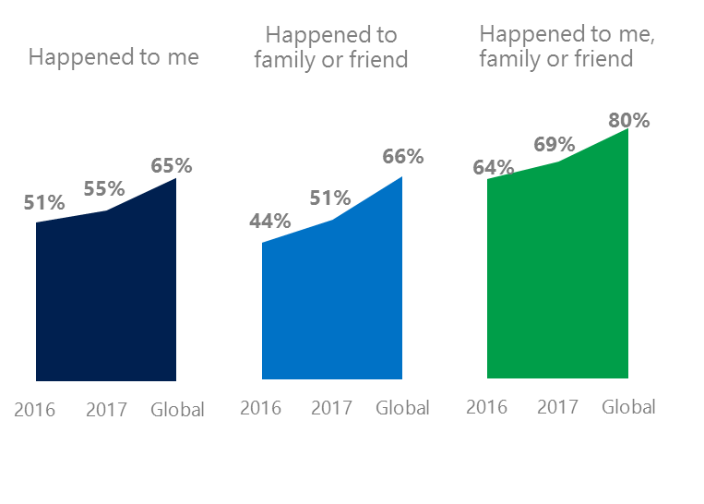Australians reported exposure to online risks for themselves, family or friends at levels significantly below the global averages.
2. Targets of online risks often named acquaintances, friends or family as perpetrators.
3. Encouraging signs emerged as people began to evolve their approaches towards the challenges of negative online interactions.
4. Millennials (ages 18-34) had the highest lifetime exposure to online risks while Baby Boomers (ages 50-74) reported the highest level of civil behavior.
5. The consequences from bullying and harassment were higher for females and teens than males and adults.

New risks drove Intrusive category higher



1Australia DCI was 55%

Australia ranked third out of 23 countries for exposure to online risks with DCI up four points since 2016. In 2017, we maintained and added two risks to the Intrusive category and one risk to Behavioral. Without these changes, DCI would have been two points lower at 49%.

**Intrusive:** Unwanted Contact (30%) trended down five points YOY but remained the most prevalent risk. Hoaxes, Scams & Frauds (28%) was ranked second highest among all risks and was like the global average.

**Behavioral:** Behavioral risks were under the global average by six points. One in four had experienced being Treated Mean (25%) which was the third highest risk in Australia and was four points above the global average.

**Sexual:** Slightly under one in five had experienced a Sexual risk like 2016. Australians reported below average exposure to Sexual risks compared to the global averages.

**Reputational:** Overall, Reputational risks were six points lower than the global average with Damage to Personal Reputation (5%) being the most common.2Targets of online risks often named 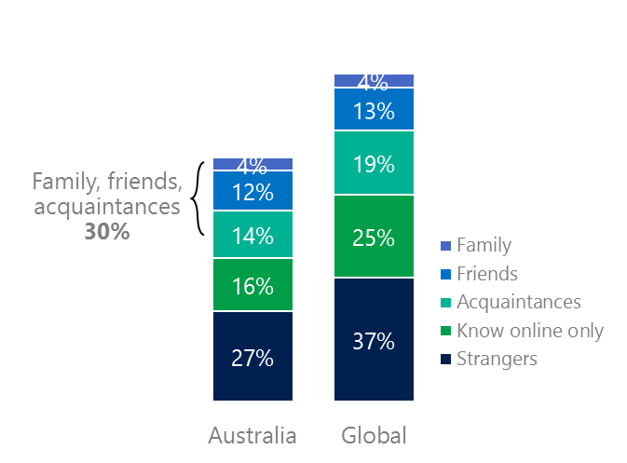people they knew as perpetrators

30% of perpetrators were family, friends, acquaintances

(among those who said they were treated unsafely or uncivilly)

Although many believe online risks are facilitated by the anonymity provided by the internet, these experiences often involved people they knew personally including family and friends (30%) compared to 36% globally. 38% had met their perpetrator in real life which was down seven points from 2016 and 15 points less than the global average (53%). Among those who had met their perpetrator, 90% met before the risk occurred second only to the UK (94%). Familiarity with the perpetrator in real life was related to an increased exposure to online risks. The average number of risks was 87% higher among those who had met the perpetrator in real life vs. those who had not (5.2 vs. 2.8).

Familiarity with the perpetrator in real life also affected exposure to consequences. Over six in 10 respondents (62%, -4 points) suffered at least one consequence from online risks with loss of trust online and offline being the most common. Among those who had met their perpetrator in real life, 61% lost trust in others online and 57% lost trust in others offline. This compared to a loss of trust online (37%) and offline (13%) for those who had not met the perpetrator in real life.

Loss of trust was the biggest consequence

3 Encouraging signs emerged

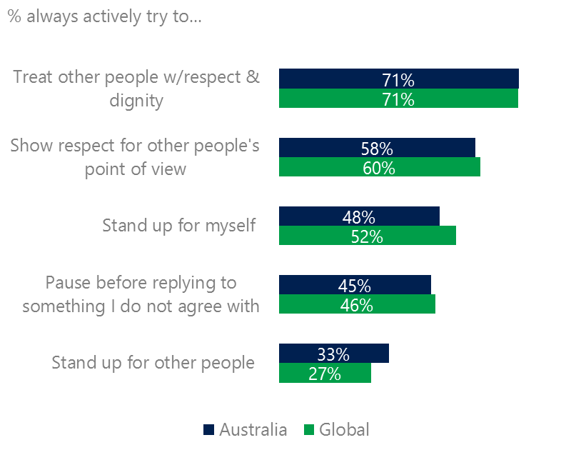Argentines exceeded the global averages for civil behavior as defined by the Microsoft Digital Civility Challenge, announced in 2017. A clear majority of respondents stated that they actively tried to treat others with respect and dignity (78%, 71%), gave respect to other’s point of view (65%, 60%), protected themselves (60%, 52%) and paused before replying to someone they disagreed with (60%, 46%).

Reports of civil behavior were widespread

56% of respondents said they were extremely or very confident in managing online risks compared to 46% globally and more people knew where to find help if needed (50%, 45%).

Females were more likely than males to treat others with respect and dignity (80%, 75%) and to show respect for other’s points of view (62%, 58%). Males were more likely to stand up for other people than females (32%, 24%). Respondents ages 50-74 reported the highest levels of civil behavior.

4 Millennials had the highest lifetime risk exposure

Nearly eight in 10 Millennials experienced a consequence from online risks

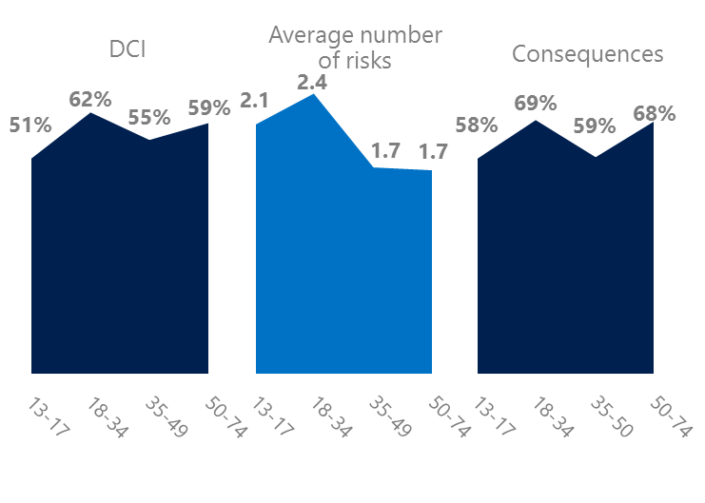Millennial generation respondents (ages 18-34) had the highest levels of risk exposure as measured by DCI (62%) consequences from risks (69%) and average number of risks (2.4). One possible explanation for these high levels is that Millennials were the first generation to grow up in a digital, media-saturated world with abundant free time to explore and experiment. 12% of Millennials said they were not treated in a safe or civil manner online. Over one in three Millennials (35%) were extremely or very concerned about online risks, the highest among all age groups.

Conversely, the Baby Boom generation (ages 50-74) had the lowest average number of risks (2.2), consequences from risks (63%) and concerns about online risks (20%). More importantly, this age group reported some of the highest levels of civil behavior online as defined by the Microsoft Digital Civility Challenge, announced in 2017. They were more likely to treat others with respect and dignity and to be thoughtful in online exchanges when people disagreed. Younger generations were more likely than Boomers to stand up for themselves and for others.

Boomers were the most respectful & civil

5 Consequences from harassment were more likely to affect females and teens

Australia had the third lowest rate of harassment (40%) among the 23 countries surveyed. This study defined harassment as Unwanted Contact, Unwanted Sexting, Online Harassment, Cyberbullying or Misogyny. Adults reported higher levels of Unwanted Contact than teens (ages 13-17) while the incidence of Online Harassment and Cyberbullying was higher for teens. Unsurprisingly, females were more likely to report Misogyny than males (8%, 1%).

Four in 10 people were harassed

The severity of consequences from all forms of harassment was higher for females and teens than males and adults. Females were 22 points higher than males on Loss of trust offline and 12 points higher on lost trust in people online. Teens scored 23 points higher than adults on lost trust in people online, 21 points higher on had thoughts of suicide and 19 points higher on lost trust in people offline.

Definitions of online risks

1. **Cyberbullying:** When the Internet, phones or other devices are used to send or post text, images, or video intended to hurt, embarrass or intimidate another person.
2. **Damage to Personal reputation:** Damage or destruction to the image created of you through PERSONAL information you or others shared online in blogs, postings, pictures, tweets, videos, etc.
3. **Damage to Professional/Work reputation:** Damage or destruction to the image created of you through work information you or others shared online in blogs, postings, pictures, tweets, videos, etc.
4. **Discrimination:** A person who is discriminated against or excluded based on gender, ethnic origin, religion, race, disability, or sexual orientation.
5. **Doxxing:** The process of collecting and distributing or posting information about a person (e.g., name, age, email, address, phone number, photographs, etc.) without their permission.
6. **Hate speech:** speech that attacks a person or group based on gender, ethnic origin, religion, race, disability, or sexual orientation.
7. **Hoaxes, scams, frauds:** The spreading of false rumors (e.g., chain letters), criminal attempts to obtain personal information often for monetary gain (e.g., phishing scams), malicious emails disguised as someone you know (e.g. virus).
8. **Microaggression:** Casual insults made towards any marginalized group in society (e.g., religious or ethnic minorities, women, LGBT, people with disabilities, etc.).
9. **Misogyny**: An expression or demonstration of dislike, contempt for, or ingrained prejudice against women.
10. **Online harassment:** Threats or other offensive behavior (not sexual solicitation) sent online or posted online for others to see.
11. **Revenge pornography:** A sexually explicit portrayal of one or more people distributed without their consent.
12. **Sextortion:** When someone threatens to distribute your private and sensitive material if you don’t provide them images of a sexual nature, sexual favors, or money. The perpetrator may also threaten to harm your friends or relatives by using information they have obtained from your electronic devices unless you comply with their demands.
13. **Sexual solicitation:** A person who requests to engage in sexual activities or sexual talk or to give personal sexual information that is unwanted.
14. **Swatting:** The act of deceiving emergency services (e.g., police, fire, medical) into sending an emergency response based on the false report of an ongoing critical incident or crime.
15. **Terrorism recruiting:** An attempt by a terrorist or terrorist organization to recruit a person for the purposes of causing harm.
16. **Treated Mean:** Words or messages sent to another person online that are unkind, unfair or malicious.
17. **Trolling:** A deliberate act to make someone mad or angry using online or social media comments in a clever, but deceitful manner.
18. **Unwanted Sexting Sent:** I sent unwanted sexually explicit messages and imagery.
19. **Unwanted Sexting Received:** Received unwanted sexually explicit messages and imagery.
20. **Unwanted contact:** Being personally contacted (by phone or in person) by someone who obtained your information online but without inviting them to contact you.

1. 9 new countries: Argentina, Colombia, Peru, Hungary, Ireland, Italy, Japan, Malaysia, Vietnam

   14 Wave 1 countries: Australia, Belgium, Brazil, Chile, China, France, Germany, India, Mexico, Russia, South Africa, Turkey, UK, U.S.

   3 new online risks: Hoaxes, Frauds and Scams as one collective risk, Microaggression, Misogyny