Microsoft Digital Civility Index (DCI) 2017 – Argentina



The 2017 Civility, Safety and Interaction Online study examines the extent of negative behaviors and online interactions and their consequences. These results build on last year’s study and were based on interviews with teens ages 13-17 and adults ages 18-74. The scope of research increased to encompass 23 countries and 20 online risks (nine newly included countries, three added risks).[1]

Themes for 2017

Risk exposure exceeded the global averages the global average friends **widespread**

1. 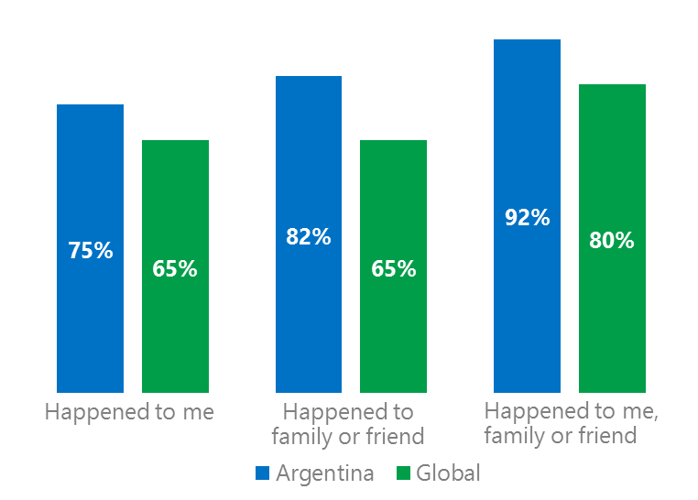Argentines reported exposure to online risks for themselves, family or friends at levels significantly above the global averages.
2. Targets of online risks often named acquaintances, friends or family as perpetrators.
3. Encouraging signs emerged as people began to evolve their approaches towards the challenges of negative online interactions.
4. Millennials (ages 18-34) had the highest lifetime exposure to online risks while Baby Boomers (ages 50-74) reported the highest level of civil behavior.
5. Consequences from bullying and harassment were higher for females than males.

Hoaxes, scams & frauds drove Intrusive risks

1Argentina DCI was 75%

Three-quarters of internet users in Argentina said they had experienced an online risk which ranked 20th out of 23 countries surveyed. Over eight in 10 had a friend or family member touched by an online risk vs. 65% globally. In 2017, we maintained and added two risks to the Intrusive category and one risk to Behavioral. Without these changes, DCI would have been three points lower to 72%.

**Intrusive:** Unwanted Contact (52%) and Hoaxes, Scams & Frauds (30%) were the two most prevalent risks. Both risks were each 10 points higher than the global average. Hate Speech and Discrimination also exceeded the global averages by significant margins.

**Behavioral:** Behavioral risks were nine points higher than the global average. Three in 10 had experienced being Treated Mean (30%) which ranked fourth highest globally behind Hungary (38%), Russia (35%) and the U.S. (31%).

**Sexual:** Nearly four in 10 had experienced a Sexual risk including Unwanted Sexting (received or sent, 30% vs. 25% globally). Sexual Solicitation was seven points higher than the global average.

**Reputational:** Damage to Personal Reputation (12%) was most common and directionally higher than the global average.

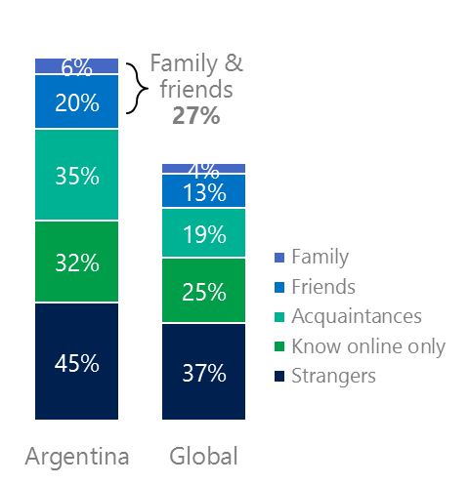2Targets of online risks often named their inner social circle as perpetrators

27% of perpetrators were family or friends

(among those who said they were treated unsafely or uncivilly)

Although many believe online risks are facilitated by the anonymity provided by the internet, these experiences often involved people they knew personally including family and friends (26%) compared to 17% globally. Not surprisingly, only 49% said they were treated in a safe and civil manner online; 16 points below the global average (65%).

Overall, six in 10 (61%) had met their perpetrator in real life versus 53% globally. Among those who had met their perpetrator, 75% met before the risk occurred. Familiarity with the perpetrator in real life was related to an increased exposure to online risks. The average number of risks was 46% higher among those who had met the perpetrator in real life vs. those who had not (4.7 vs. 3.2).

Familiarity with the perpetrator in real life also affected exposure to consequences. Seven in 10 respondents (70%) suffered at least one consequence from online risks with loss of trust online and offline being the most common. Among those who had met their perpetrator in real life, 52% lost trust in people online and 36% lost trust in people offline. This compared to lost trust in people online (38%) and offline (21%) for those who had not met the perpetrator in real life.

Loss of trust was the biggest consequence

3 Encouraging signs emerged

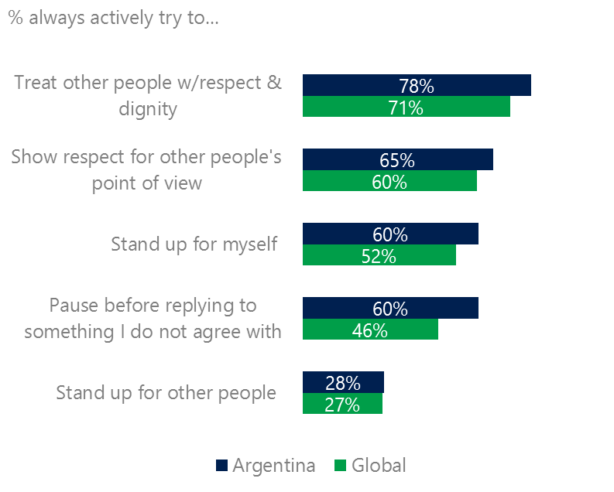Argentines exceeded the global averages for civil behavior as defined by the Microsoft Digital Civility Challenge, announced in 2017. A clear majority of respondents stated that they actively tried to treat others with respect and dignity (78%, 71%), gave respect to other’s point of view (65%, 60%), protected themselves (60%, 52%) and paused before replying to someone they disagreed with (60%, 46%).

Reports of civil behavior were widespread

56% of respondents said they were extremely or very confident in managing online risks compared to 46% globally and more people knew where to find help if needed (50%, 45%).

Females were more likely than males to treat others with respect and dignity (80%, 75%) and to show respect for other’s points of view (62%, 58%). Males were more likely to stand up for other people than females (32%, 24%). Respondents ages 50-74 reported the highest levels of civil behavior.

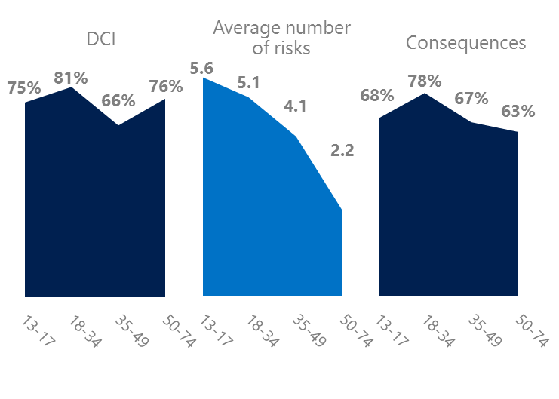4 Millennials had the highest lifetime risk exposure

Nearly eight in 10 Millennials experienced a consequence from online risks

Millennial generation respondents (ages 18-34) had the highest levels of risk exposure as measured by DCI (81%) consequences from risks (78%) and the second highest average number of risks (5.1). One possible explanation for these high levels is that Millennials were the first generation to grow up in a digital, media-saturated world with abundant free time to explore and experiment. 29% of Millennials said they were not treated in a safe or civil manner online tied with teens (ages 13-17) for the highest level of incivility. As a result, 42% of Millennials were extremely or very concerned about online risks, the highest among all age groups.

Conversely, the Baby Boom generation (ages 50-74) had the lowest average number of risks (2.2), consequences from risks (63%) and concerns about online risks (20%). More importantly, this age group reported the highest levels of civil behavior online as defined by the Microsoft Digital Civility Challenge, announced in 2017. They were more likely to treat others with respect and dignity and to be thoughtful in online exchanges when people disagreed. The one exception was Generation X which were more likely than Boomers to stand up for themselves (72%, 67%).

Boomers were the most respectful & civil

5 Females bore the brunt of consequences from harassment

Over six in 10 people were harassed

Argentina had the sixth highest rate of harassment among the 23 countries surveyed. This study defined harassment as Unwanted Contact, Unwanted Sexting, Online Harassment, Cyberbullying or Misogyny. Adults reported higher levels of harassment than teens ages 13-17 except for Cyberbullying. Females were more likely to encounter Online Harassment than males (15%, 7%).

Consequences from harassment were higher for females than males. Females were more likely to lose trust in people online and offline and have greater life stress. Adults reported higher levels of lost trust in people online (53%, 46%) and an increase in life stress (31%, 25%) than teens ages 13-17.

Definitions of online risks

1. **Cyberbullying:** When the Internet, phones or other devices are used to send or post text, images, or video intended to hurt, embarrass or intimidate another person.
2. **Damage to Personal reputation:** Damage or destruction to the image created of you through PERSONAL information you or others shared online in blogs, postings, pictures, tweets, videos, etc.
3. **Damage to Professional/Work reputation:** Damage or destruction to the image created of you through work information you or others shared online in blogs, postings, pictures, tweets, videos, etc.
4. **Discrimination:** A person who is discriminated against or excluded based on gender, ethnic origin, religion, race, disability, or sexual orientation.
5. **Doxxing:** The process of collecting and distributing or posting information about a person (e.g., name, age, email, address, phone number, photographs, etc.) without their permission.
6. **Hate speech:** speech that attacks a person or group based on gender, ethnic origin, religion, race, disability, or sexual orientation.
7. **Hoaxes, scams, frauds:** The spreading of false rumors (e.g., chain letters), criminal attempts to obtain personal information often for monetary gain (e.g., phishing scams), malicious emails disguised as someone you know (e.g. virus).
8. **Microaggression:** Casual insults made towards any marginalized group in society (e.g., religious or ethnic minorities, women, LGBT, people with disabilities, etc.).
9. **Misogyny**: An expression or demonstration of dislike, contempt for, or ingrained prejudice against women.
10. **Online harassment:** Threats or other offensive behavior (not sexual solicitation) sent online or posted online for others to see.
11. **Revenge pornography:** A sexually explicit portrayal of one or more people distributed without their consent.
12. **Sextortion:** When someone threatens to distribute your private and sensitive material if you don’t provide them images of a sexual nature, sexual favors, or money. The perpetrator may also threaten to harm your friends or relatives by using information they have obtained from your electronic devices unless you comply with their demands.
13. **Sexual solicitation:** A person who requests to engage in sexual activities or sexual talk or to give personal sexual information that is unwanted.
14. **Swatting:** The act of deceiving emergency services (e.g., police, fire, medical) into sending an emergency response based on the false report of an ongoing critical incident or crime.
15. **Terrorism recruiting:** An attempt by a terrorist or terrorist organization to recruit a person for the purposes of causing harm.
16. **Treated Mean:** Words or messages sent to another person online that are unkind, unfair or malicious.
17. **Trolling:** A deliberate act to make someone mad or angry using online or social media comments in a clever, but deceitful manner.
18. **Unwanted Sexting Sent:** I sent unwanted sexually explicit messages and imagery.
19. **Unwanted Sexting Received:** Received unwanted sexually explicit messages and imagery.
20. **Unwanted contact:** Being personally contacted (by phone or in person) by someone who obtained your information online but without inviting them to contact you.

1. 9 new countries: Argentina, Colombia, Peru, Hungary, Ireland, Italy, Japan, Malaysia, Vietnam

   14 Wave 1 countries: Australia, Belgium, Brazil, Chile, China, France, Germany, India, Mexico, Russia, South Africa, Turkey, UK, U.S.

   3 new online risks: Hoaxes, Frauds and Scams as one collective risk, Microaggression, Misogyny