Microsoft Digital Civility Index (DCI) 2017: Asia-Pacific



The 2017 Civility, Safety and Interaction Online study examines the extent of negative behaviors and online interactions and their consequences. These results build on last year’s study and were based on interviews with teens ages 13-17 and adults ages 18-74. The scope of research increased to encompass 23 countries and 20 online risks (nine newly included countries, three added risks).[1] For purposes of this report, APAC included Australia, China, India, Japan, Malaysia, and Vietnam.

Themes for 2017

Risk exposure was below the global averages

1. 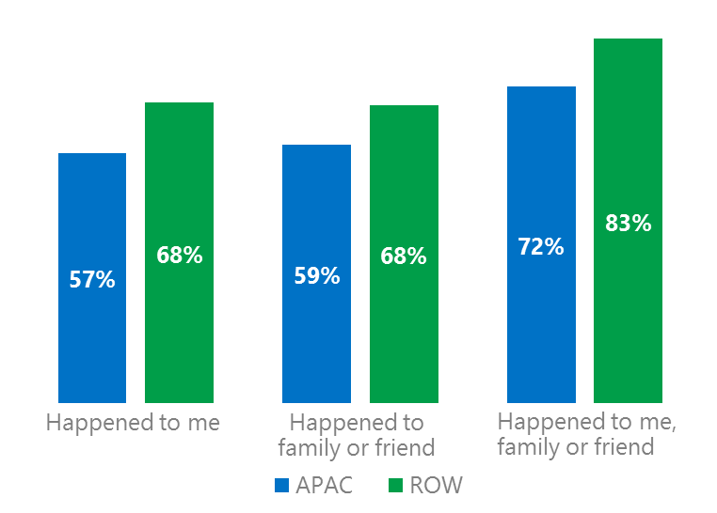Respondent’s exposure to online risks among individuals, family or friends was, on average, lower than the rest of world (ROW).[2]
2. Targets of online risks often named acquaintances, friends or family as perpetrators.
3. Encouraging signs emerged as people began to evolve their approaches towards the challenges of negative online interactions.
4. Millennials (ages 18-34) had the highest lifetime exposure to online risks while Baby Boomers (ages 50-74) reported the highest level of civil behavior.
5. The consequences from online risks were higher for females and teens than males and adults.



Over four in 10 were affected by Intrusive risks

1APAC DCI was 65%

DCI was nearly identical to the ROW average. Broader measures of risk exposure that included family and friends were also close to the ROW averages. In 2017, we maintained and added two risks to the Intrusive category and one risk to Behavioral. Without these changes, DCI would have been two points lower to 62%.

**Intrusive:** These risks were 14 points below the ROW average driven by Unwanted Contact (30%) and Hoaxes, Scams & Frauds (23%). Vietnam had the highest Intrusive score (55%) while Japan had the lowest (18%).

**Behavioral:** Behavioral risks were five points below the ROW average led being Treated Mean (16%) and Microaggression (8%). Malaysia scored highest at 44% with the lowest score in Japan (17%).

**Sexual:** The category was five points below the ROW average led by Unwanted Sexting Received or Sent (23%). The highest score was in Vietnam (36%) and Australia the lowest (18%).

**Reputational:** The category was equal to the ROW average. Reputational risks were highest in Vietnam (26%) and lowest in Japan (9%). 2Targets of online risks often named 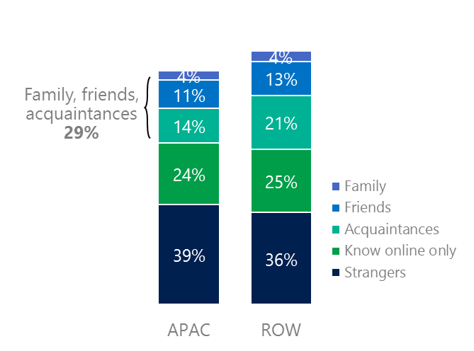people they knew as perpetrators

29% of perpetrators were family, friends or acquaintances

(among those who said they were treated unsafely or uncivilly)

Although many believe online risks are facilitated by the anonymity provided by the internet, these experiences often involved people they knew personally including family, friends or acquaintances (29%) compared to 38% ROW. Slightly under six in 10 respondents (57%) had met their perpetrator in real life which was seven points less than the ROW average (64%). Among those who had met their perpetrator, 76% met before the risk occurred four points lower than the ROW average. Familiarity with the perpetrator in real life was related to an increased exposure to online risks. The average number of risks was 74% higher among those who had met the perpetrator in real life vs. those who had not (4.8 vs. 2.7).

Familiarity with the perpetrator in real life also affected exposure to consequences. Overall, nearly seven in 10 respondents (69%) suffered at least one negative consequence from online risks with loss of trust online and lost sleep being the most common. Among those who had met their perpetrator in real life, 48% lost trust in other people online and offline (39%) and 39% lost sleep. This compared to lost trust in other people online (34%) and offline (17%) and lost sleep (20%) for those who had not met the perpetrator in real life.

Loss of trust was the biggest consequence

3 Encouraging signs emerged

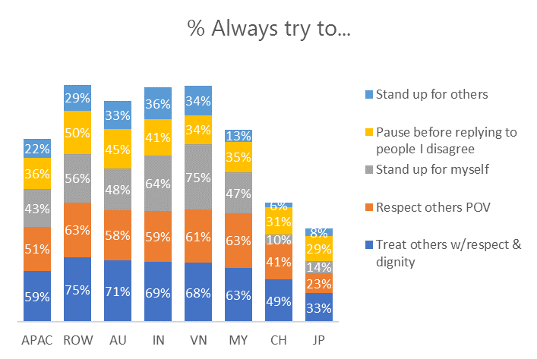Most respondents in Australia, India, Vietnam and Malaysia stated that they actively tried to treat others with respect and dignity and over half showed respect to other people’s point of view. The lower scores in China and Japan may be due to cultural factors that manifest themselves in a mild response style where less extreme scale points are preferred over the extremes. Evidence for this phenomenon was found as respondents in China and Japan had the highest middle box (i.e., occasionally) scores across all five civil behaviors.

Japan & China reported the lowest levels of civil behavior in APAC

37% of respondents said they were extremely or very confident in managing online risks; 13 points below the ROW (50%) and 36% knew where to find help if needed compared to 48% ROW.

Females were more likely than males to treat others with respect and dignity (61%, 56%), respect other people’s point of view (52%, 49%) and to pause before replying to someone they disagreed with (39%, 33%). Adults were more likely than teens to pause before replying to someone they disagreed with (38%, 34%) while teens more than adults stood up for other people (24%, 20%).

4 Millennials had the highest lifetime exposure to risks & their consequences

Over three in four Millennials experienced a consequence from online risks

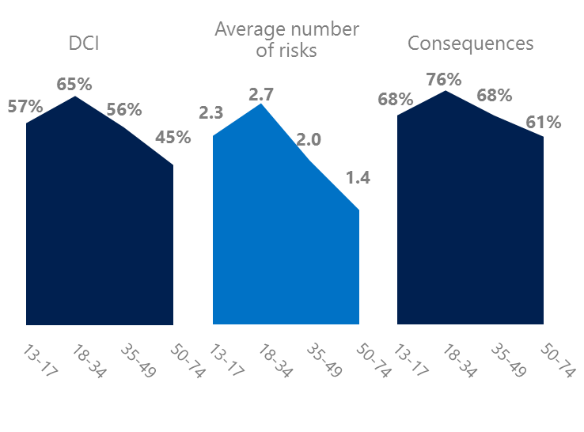Millennial generation respondents (ages 18-34) had the highest levels of risk exposure as measured by DCI (65%), average number of risks (2.7) and consequences from risks (76%). One possible explanation for these high levels is that Millennials were the first generation to grow up in a digital, media-saturated world with abundant free time to explore and experiment. 11% of Millennials said they were not treated in a safe or civil manner online, highest among all age groups. Not surprisingly, nearly six in 10 Millennials (57%) were extremely or very concerned about online risks which was 18 points higher than the combined non-Millennial age group average.

Conversely, the Baby Boom generation (ages 50-74) had the lowest DCI (45%), average number of risks (1.4) and consequences from risks (61%) and concerns about online risks (31%). More importantly, this age group reported some of the highest levels of civil behavior online as defined by the Microsoft Digital Civility Challenge, announced in 2017. They were more likely to treat others with respect and dignity and to be thoughtful in online exchanges when people disagreed.

Respondents under 35 were more likely to stand up for themselves and others

5 Consequences from harassment were more likely to affect females and teens

Over four in 10 respondents experienced harassment, 11 points below the ROW average. This study defined harassment as Unwanted Contact, Unwanted Sexting, Online Harassment, Cyberbullying or Misogyny. Rates of harassment did not differ significantly by age or gender.

Over four in 10 people were harassed

However, the consequences from all forms of harassment were higher for females than males. Females were nine points higher than males on life became more stressful, six points higher on became depressed and five points higher on lost trust in people offline. Like females, teens reported higher levels of consequences than adults across all forms of harassment. The largest gaps were on lost trust in people online (+14 points) and offline (+13 points) and became depressed (+12 points).

Definitions of online risks

1. **Cyberbullying:** When the Internet, phones or other devices are used to send or post text, images, or video intended to hurt, embarrass or intimidate another person.
2. **Damage to Personal reputation:** Damage or destruction to the image created of you through PERSONAL information you or others shared online in blogs, postings, pictures, tweets, videos, etc.
3. **Damage to Professional/Work reputation:** Damage or destruction to the image created of you through work information you or others shared online in blogs, postings, pictures, tweets, videos, etc.
4. **Discrimination:** A person who is discriminated against or excluded based on gender, ethnic origin, religion, race, disability, or sexual orientation.
5. **Doxxing:** The process of collecting and distributing or posting information about a person (e.g., name, age, email, address, phone number, photographs, etc.) without their permission.
6. **Hate speech:** speech that attacks a person or group based on gender, ethnic origin, religion, race, disability, or sexual orientation.
7. **Hoaxes, scams, frauds:** The spreading of false rumors (e.g., chain letters), criminal attempts to obtain personal information often for monetary gain (e.g., phishing scams), malicious emails disguised as someone you know (e.g. virus).
8. **Microaggression:** Casual insults made towards any marginalized group in society (e.g., religious or ethnic minorities, women, LGBT, people with disabilities, etc.).
9. **Misogyny**: An expression or demonstration of dislike, contempt for, or ingrained prejudice against women.
10. **Online harassment:** Threats or other offensive behavior (not sexual solicitation) sent online or posted online for others to see.
11. **Revenge pornography:** A sexually explicit portrayal of one or more people distributed without their consent.
12. **Sextortion:** When someone threatens to distribute your private and sensitive material if you don’t provide them images of a sexual nature, sexual favors, or money. The perpetrator may also threaten to harm your friends or relatives by using information they have obtained from your electronic devices unless you comply with their demands.
13. **Sexual solicitation:** A person who requests to engage in sexual activities or sexual talk or to give personal sexual information that is unwanted.
14. **Swatting:** The act of deceiving emergency services (e.g., police, fire, medical) into sending an emergency response based on the false report of an ongoing critical incident or crime.
15. **Terrorism recruiting:** An attempt by a terrorist or terrorist organization to recruit a person for the purposes of causing harm.
16. **Treated Mean:** Words or messages sent to another person online that are unkind, unfair or malicious.
17. **Trolling:** A deliberate act to make someone mad or angry using online or social media comments in a clever, but deceitful manner.
18. **Unwanted Sexting Sent:** I sent unwanted sexually explicit messages and imagery.
19. **Unwanted Sexting Received:** Received unwanted sexually explicit messages and imagery.
20. **Unwanted contact:** Being personally contacted (by phone or in person) by someone who obtained your information online but without inviting them to contact you.

1. 9 new countries: Argentina, Colombia, Peru, Hungary, Ireland, Italy, Japan, Malaysia, Vietnam

   14 Wave 1 countries: Australia, Belgium, Brazil, Chile, China, France, Germany, India, Mexico, Russia, South Africa, Turkey, UK, U.S.

   3 new online risks: Hoaxes, Frauds and Scams as one collective risk, Microaggression, Misogyny
2. ROW countries: Argentina, Belgium, Brazil, Chile, Colombia, France, Germany, Hungary, Ireland, Italy, Mexico, Peru, Russia, South Africa, Turkey, U.K, U.S.